

Amazon AWS Workshop

*LAB GUIDE*

*By*

CloudSiksha

* Check if these pre-requisites are met
  + You have an Amazon account. Else create one
  + In case you are running a Linux instance and want to connect using Windows, ensure you have downloaded the following software (all of them are free)
    - PuTTY
    - PuttyGen
    - FileZilla
  + In case you are using a Linux system, ensure the SSH and FTP services are running

Important Note (Disclaimer):

We have tried to design the labs in such a way that we make use of the free tier and the participant incurs no charge. Yet it is possible that due to extra work done by the participants on their own or not terminating some instances, not releasing storage or due to change in Amazon pricing policy or any other factor some fee may be incurred. We are not responsible for any charge that gets levied by Amazon for usage as part of this lab.

Contents

Exercise 1 6

Launching a Linux EC2 Instance and Logging into the instance 6

Launching an instance 6

Exercise 2 7

Transferring files to your Amazon Instance 7

Transferring Files to Amazon Instance from a Linux System 8

Transferring files to Amazon Instance from Windows 9

Exercise 3 11

Stopping and Restarting an Instance 11

Exercise 4 15

Assigning and Releasing Elastic IP address 15

Assigning Elastic IP Address 16

Releasing Elastic IP Addresses 19

Exercise 5 21

Using S3 21

Uploading files to S3 22

Downloading objects from S3 32

Setting permissions and viewing objects stored in S3 34

Removing permissions 37

Hosting a Static Website 38

Storing with Reduced Redundancy or Infrequent Access 42

Deleting Objects 43

Exercise 6 44

Building a VPC 44

Creating a VPC 45

Creating subnets 48

Creating Internet Gateway 51

Creating Routing Table 54

Launching instances into subnets 57

Attaching Elastic IP and connecting to Internet Gateway 59

Logging into the Private Instance 62

Exercise 7 63

Creating a NAT Gateway 63

Exercise 8 68

Identity and Access Management (IAM) 68

Creating an administrative user 69

Creating Groups and assigning users 76

Creating Role and Assigning Role to an EC2 Instance 80

# Exercise 1

## Launching a Linux EC2 Instance and Logging into the instance

EC2 is the basic compute instance on the Cloud and forms the foundation for many of the features in Amazon. This exercise will provide step-by-step instruction on how to launch an EC2 instance.

### Launching an instance

Kindly click on the below youtube link. This CloudSiksha channel on youtube gives a detailed step by step process for starting a Linux as well as Windows instance

<https://www.youtube.com/watch?v=RpQob8M8Rqc>

Logging into the instance

To login into a Linux instance watch this CloudSiksha video given below:

<https://www.youtube.com/watch?v=MBb2oJnTqRY>

To login into a Windows instance watch this CloudSiksha video given below:

<https://www.youtube.com/watch?v=ahALycfEX0o>

# Exercise 2

## Transferring files to your Amazon Instance

One of the tasks which you definitely have to perform after starting an instance is to transfer files to the instance. This can be done using multiple FTP Client software in Windows. We will use FileZilla for our exercise. This is a free software. (You can use any other FTP software like CoreFTP etc. if you so desire). In case of Linux we will use the Secure Copy, scp, command to transfer files.

### Transferring Files to Amazon Instance from a Linux System

Files can be transferred from a Linux system to an Amazon Instance using the Secure Copy (scp) command. Issue the following command

$ scp –i <*.pem file> <sourcefile> ec2-user@<destIP>:/<path to file>

Ex :

$ scp –i CloudSiksha.pem testtransfer.c [ec2-user@52.159.87:/home/ec2-user](mailto:ec2-user@52.159.87:/home/ec2-user)

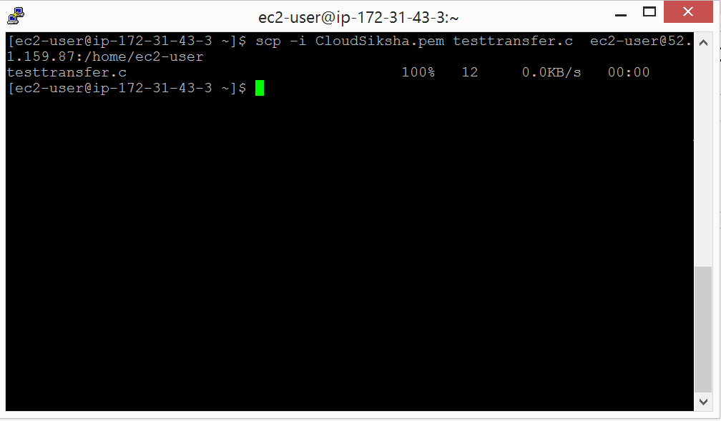

### Transferring files to Amazon Instance from Windows

We can use any FTP client to transfer files from Windows. We will use the FileZilla client to transfer files to the Amazon Instance

The FileZilla Client can be downloaded from:

<https://filezilla-project.org/download.php?type=client>

Open FileZilla Client and go to ‘Edit’ 🡪 ‘Settings’. Select ‘SFTP’ under ‘FTP’ and click on ‘Add KeyFile’

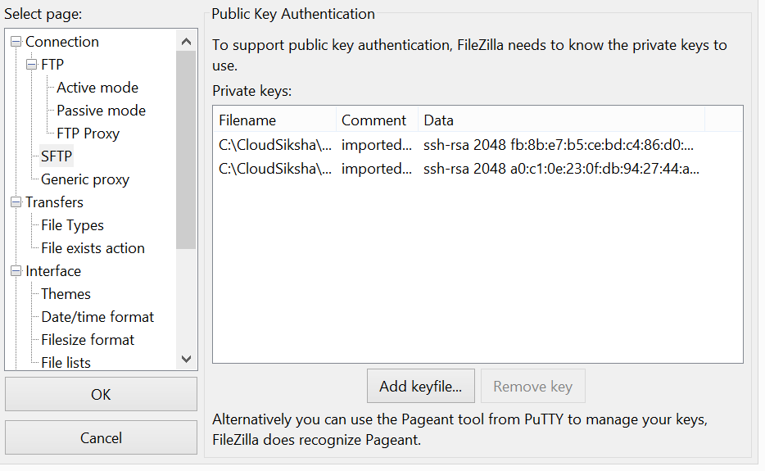

Input the *.ppk file you had saved earlier.

***(Remember: Whenever it is Windows use the *.ppk file. User *.pem in Linux)***

Click ‘OK’ after your select your keyfile

In the FileZilla main screen, input the IP Address of the instance, User is ‘ec2-user’ and Port ‘22’ and press ‘Quick Connect’

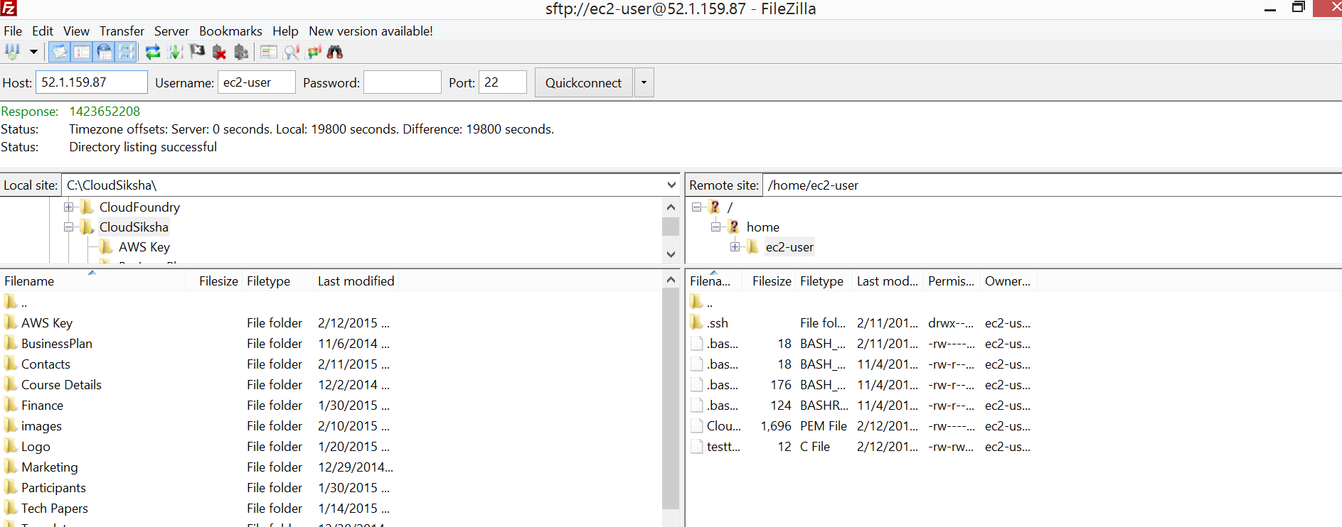

The local directories are listed on the left and the Amazon Instance files are listed on the right. You can now drag and drop files into the Amazon Instance

# Exercise 3

## Stopping and Restarting an Instance

This is a simple exercise which teaches the user how to start, stop and terminate an EC2 instance

From EC2 Dashboard, click on ‘Running Instance’ to bring up the Instance Dashboard. Select the Instance you want to Stop and Click on ‘Actions’🡪’Instance State’🡪’Stop’

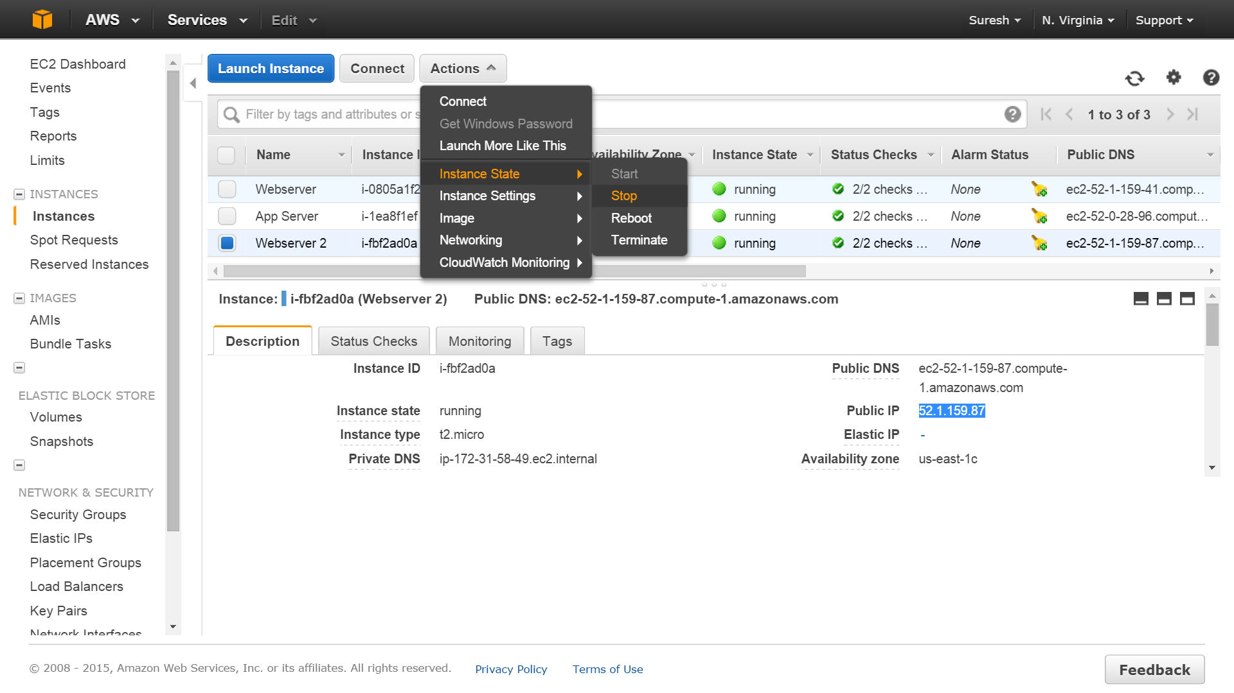

Press ‘Yes’ when the warning comes up. The instance will shut down

To start an instance, select the instance you want to Start and Click on ‘Actions’🡪’Instance State’🡪’Start’

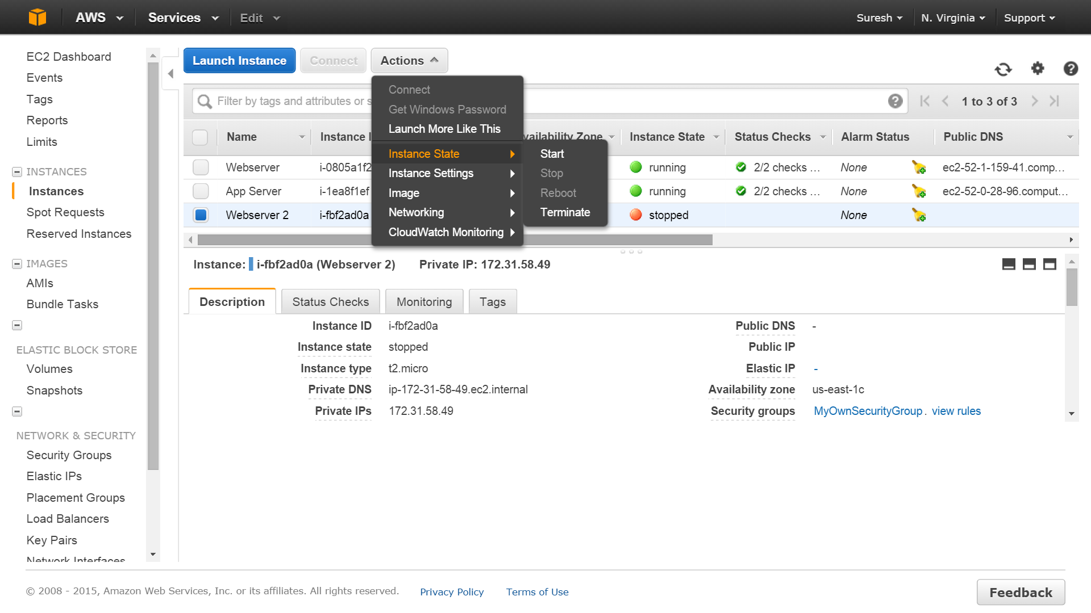

To terminate an instance select the instance you want to terminate and click on ‘Actions’🡪’Instance State’🡪’Terminate’

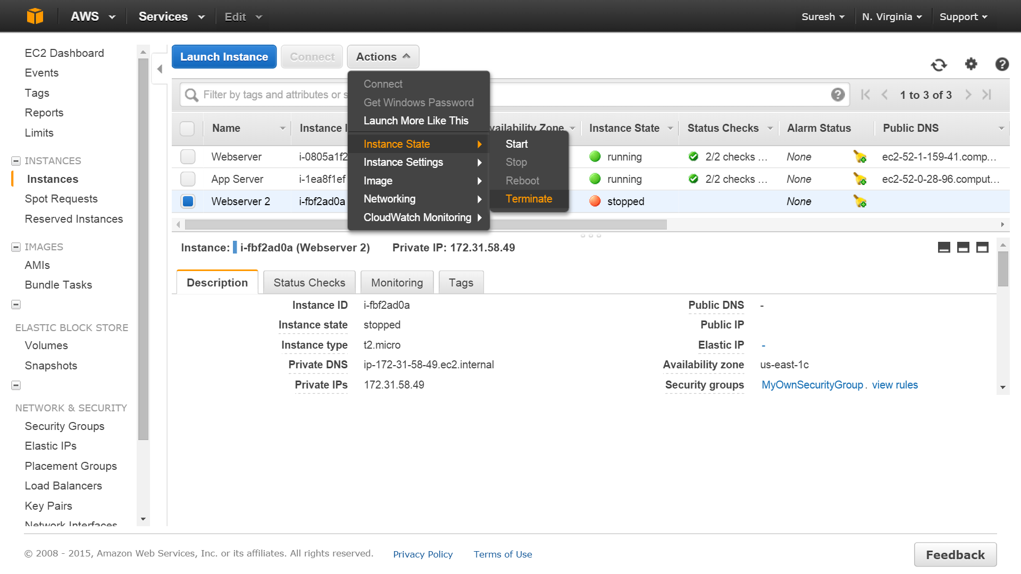

# Exercise 4

## Assigning and Releasing Elastic IP address

All instances will be assigned a Public IP by default but these IP keep changing when you restart the instance. If you need a static Public IP you need to use the Elastic IP for this purpose. This exercise will show you how to attach and detach an Elastic IP to an instance

### Assigning Elastic IP Address

Select ‘Elastic IP’ from the EC2 Dashboard. This will bring up the ‘Allocate New Address’ screen. Press the ‘Allocate New Address’ button

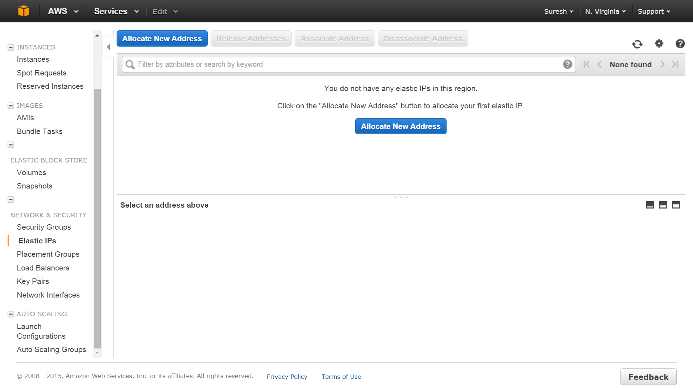

Say ‘Yes’ in the popup menu

You will now be allocated a permanent static IP. You need to associate this IP with an instance. (Remember, Amazon does not charge for Elastic IP if it associated with a running instance. If you stop the instance you will be charged.)

Select the address you have obtained and click on ‘Associate Address’

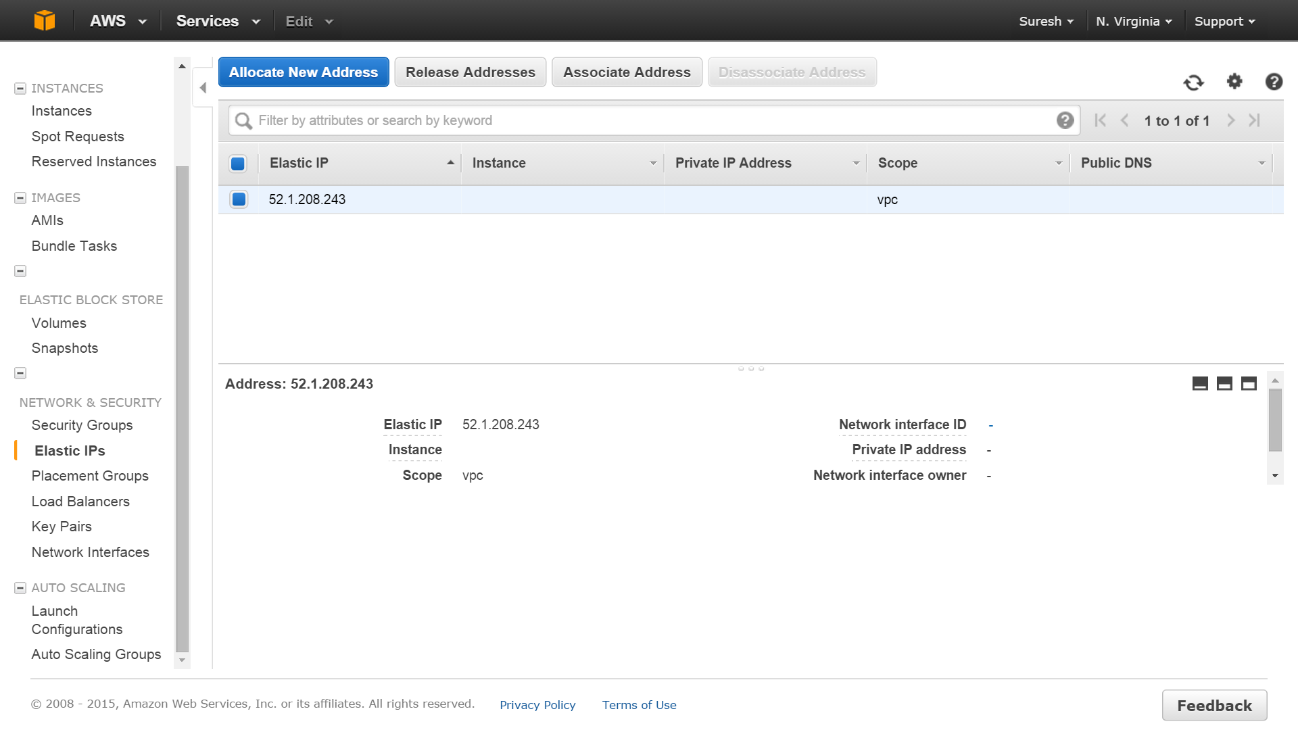

Select the Instance to which you want to associate the IP with and click ‘Associate’

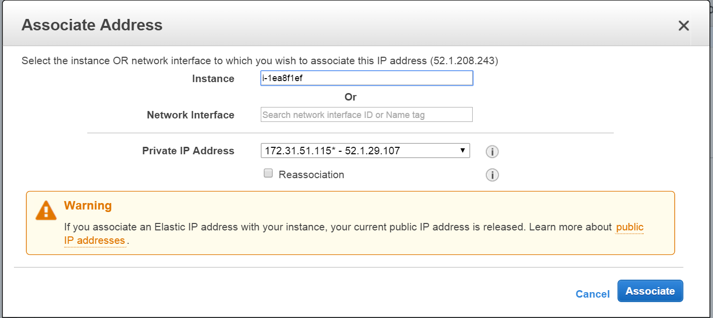

The IP will now be associated with the instance you had selected

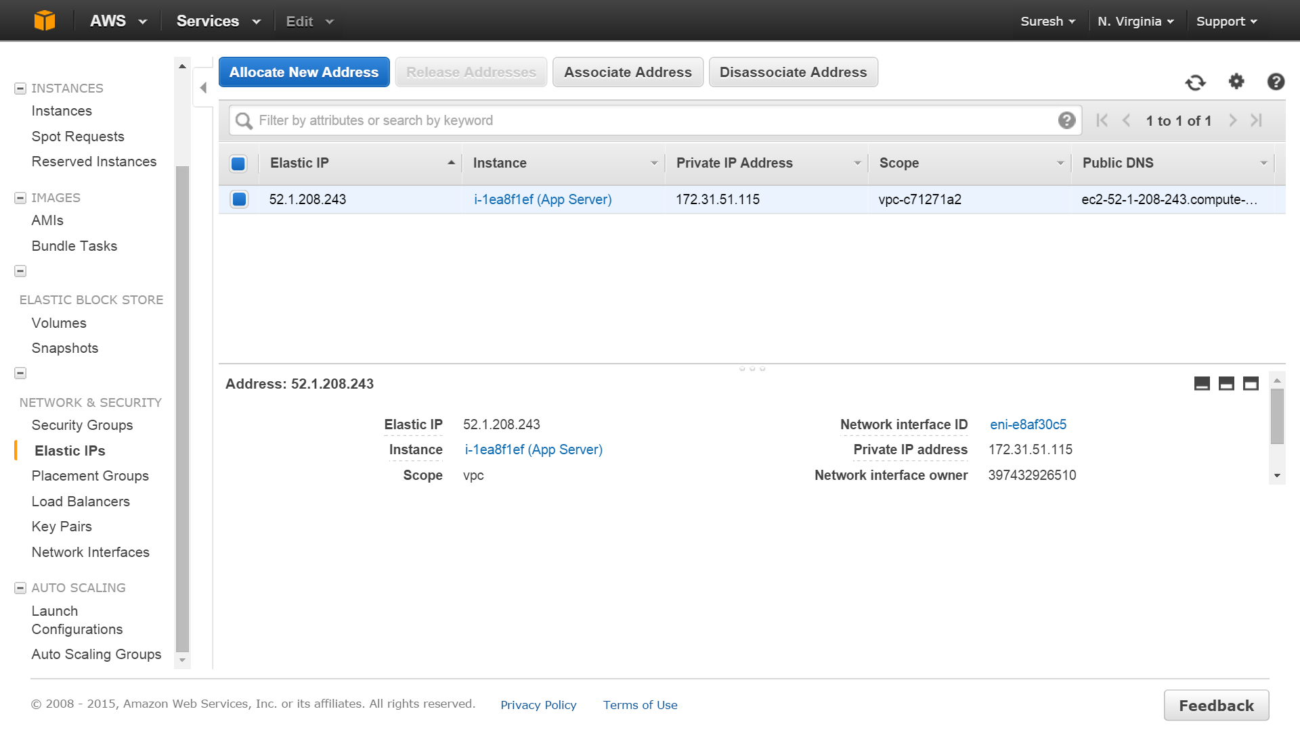

### Releasing Elastic IP Addresses

We must first dissociate the Elastic IP before we can release it.

Go to Elastic IP screen, select the Elastic IP you want to release and press ‘Dissociate Address’

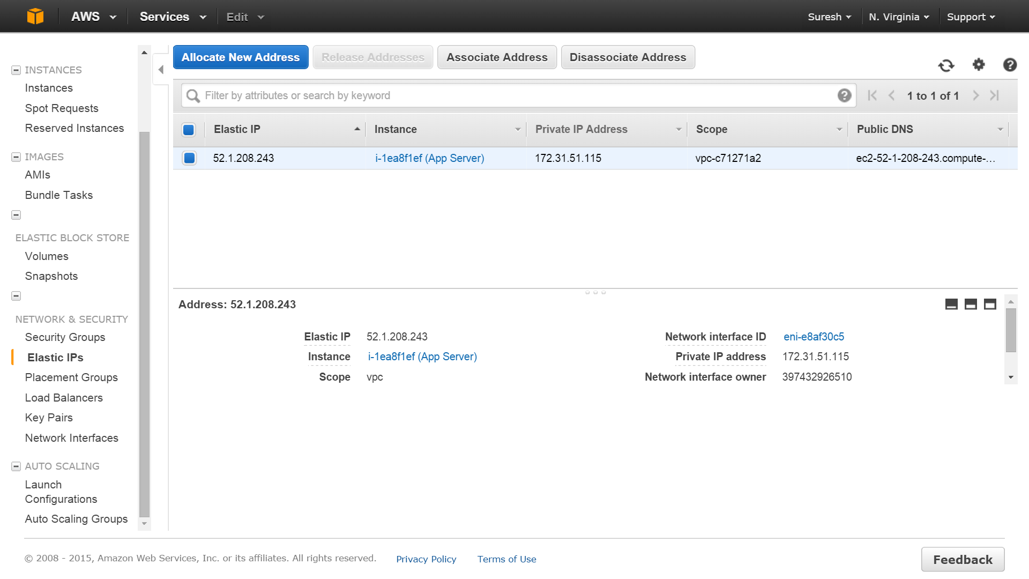

In the popup screen press, ‘Yes, Dissociate’

Once the IP is dissociated from the instance, choose the IPs you want to release and press the ‘Release Addresses’ button. In the popup, press ‘Yes, Release’ button



This will release the Elastic IP back to the AWS pool.

# Exercise 5

## Using S3

This exercise teaches you how to access the Simple Storage Service (S3) of Amazon. We will upload a few objects, understand how to access them and later we will delete these objects. For free tier, Amazon provides 5GB of space free of cost. Hence ensure that the size of all objects put together that you store in S3 is less than this limit in order to not incur any cost. Amazon also has a cost associated with the number of GETS and PUTS as well as cost associated with download. In our exercises we should not exceed these limits.

### Uploading files to S3

From the AWS Console (<http://console.aws.amazon.com>) choose S3

In the Welcome screen click on ‘Create Bucket’

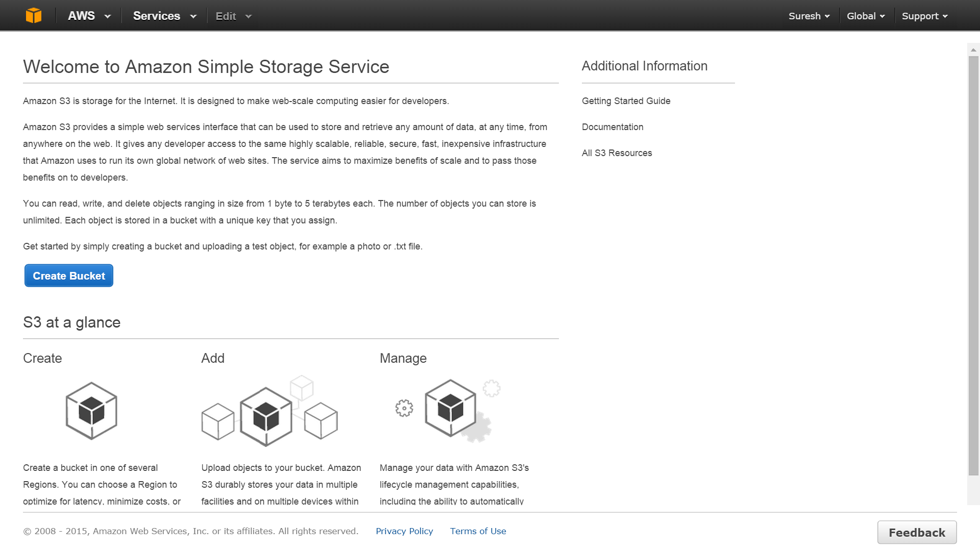

A ‘Create Bucket’ screen will pop up. In this enter the name of the bucket. The name should be unique across all regions of AWS. (It means your name will be rejected if bucket with same name already exists within S3 infrastructure). You name must not be capital letters. Choose the US Standard region for this exercise. (You can choose any region you want. Pricing will depend on the region chosen). Then click ‘Create’

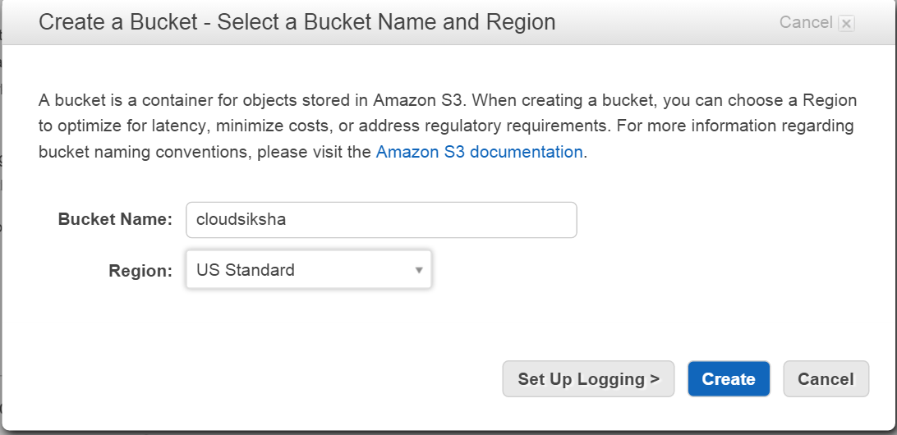

This will lead us to the S3 Management Screen

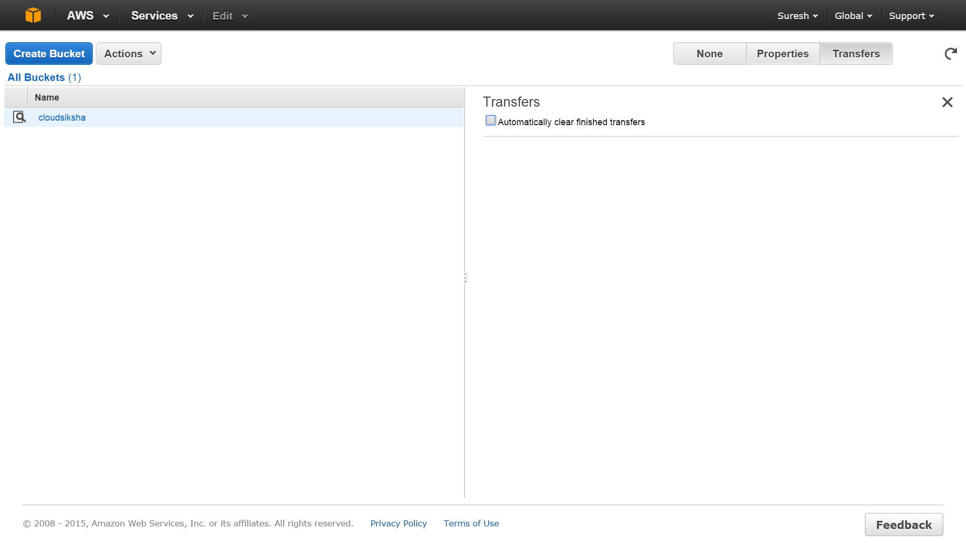

Let us create one more bucket by clicking on ‘Create Bucket’



Choose a different name for this bucket. Choose the US Standard region and create the bucket

Now you have two buckets at your disposal. Click on the first bucket name. It will lead us into the bucket. Once you are inside a bucket you can upload an object into the bucket. In this bucket let us upload an object directly. Click on ‘Actions’🡪’Upload’

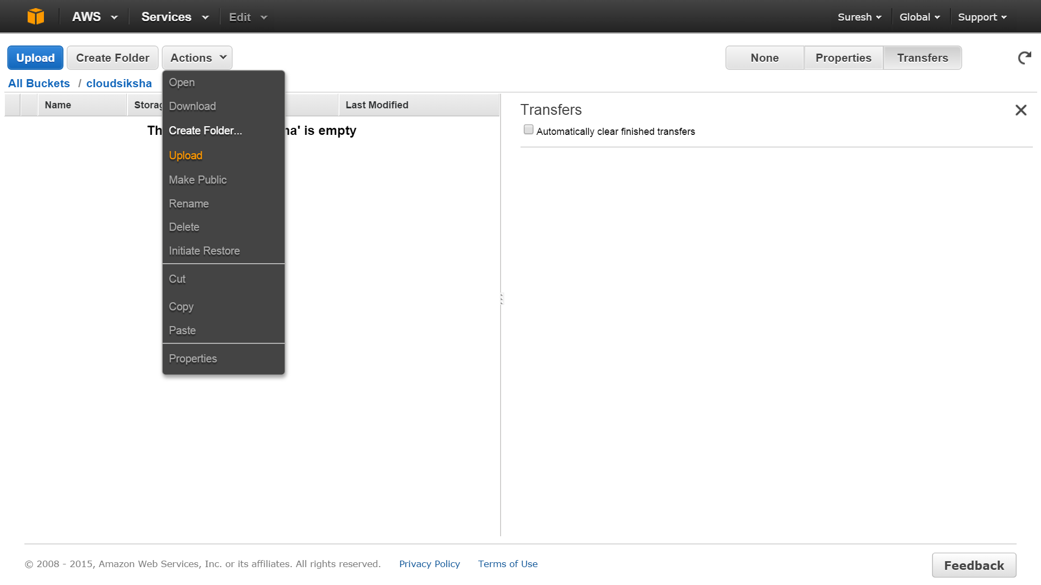

In the Upload files popup you can either use ‘Add Files’ to select a file from your computer or you can directly drag and drop any file into this popup. For this exercise choose a picture file which is present in your computer. Once you have selected / dropped the file, click on ‘Start Upload’

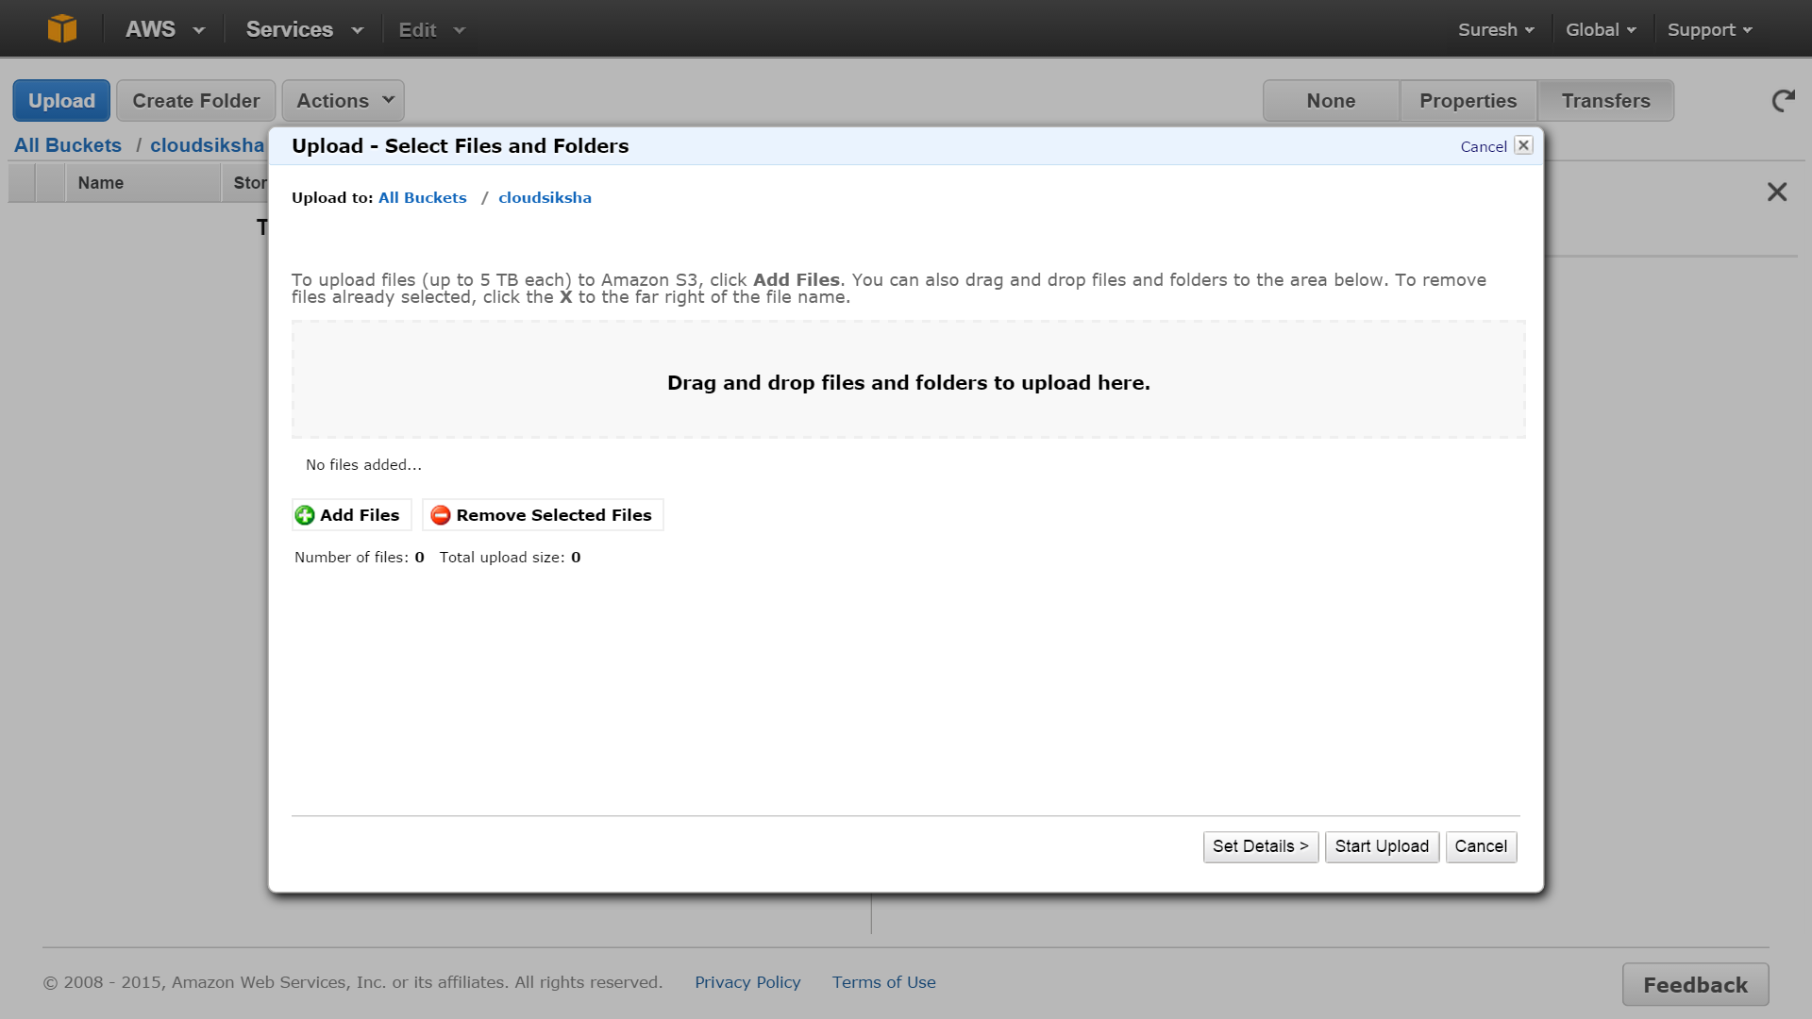

The file name will appear once the upload is completed

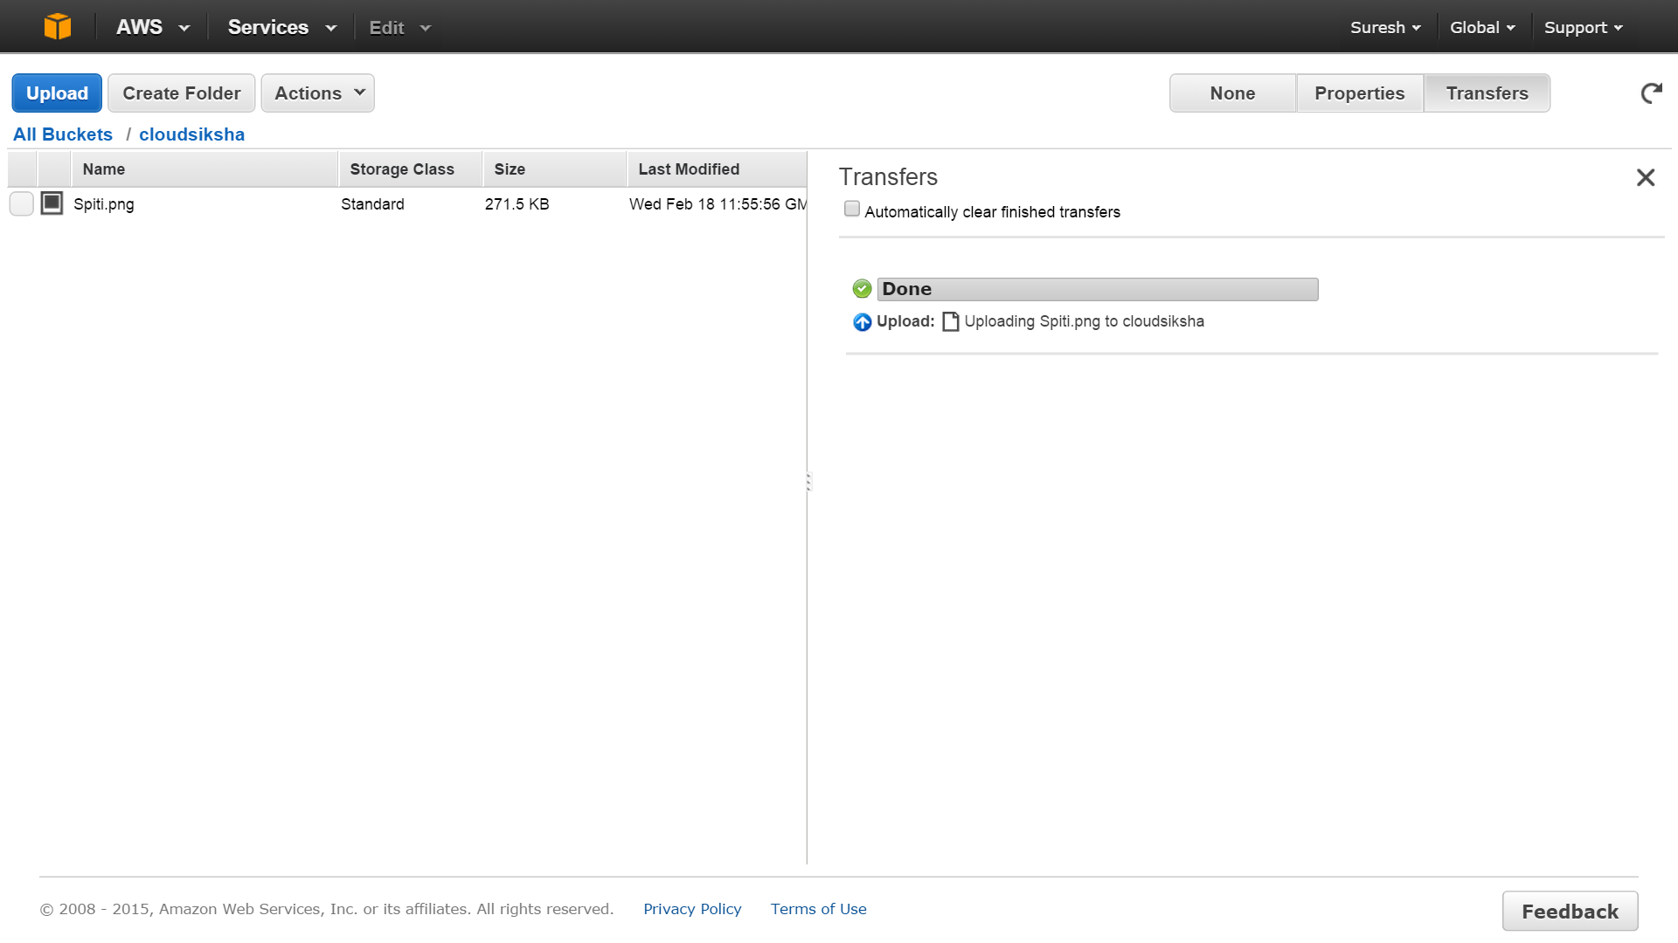

You have now successfully uploaded an object into S3

Let us now create a folder and upload an object in the second bucket we have created.

Click on the ‘All Buckets’ link to go back to the main bucket screen.



Now choose the second bucket you have created. After you are in the second bucket, choose ‘Actions’🡪’Create Folder’

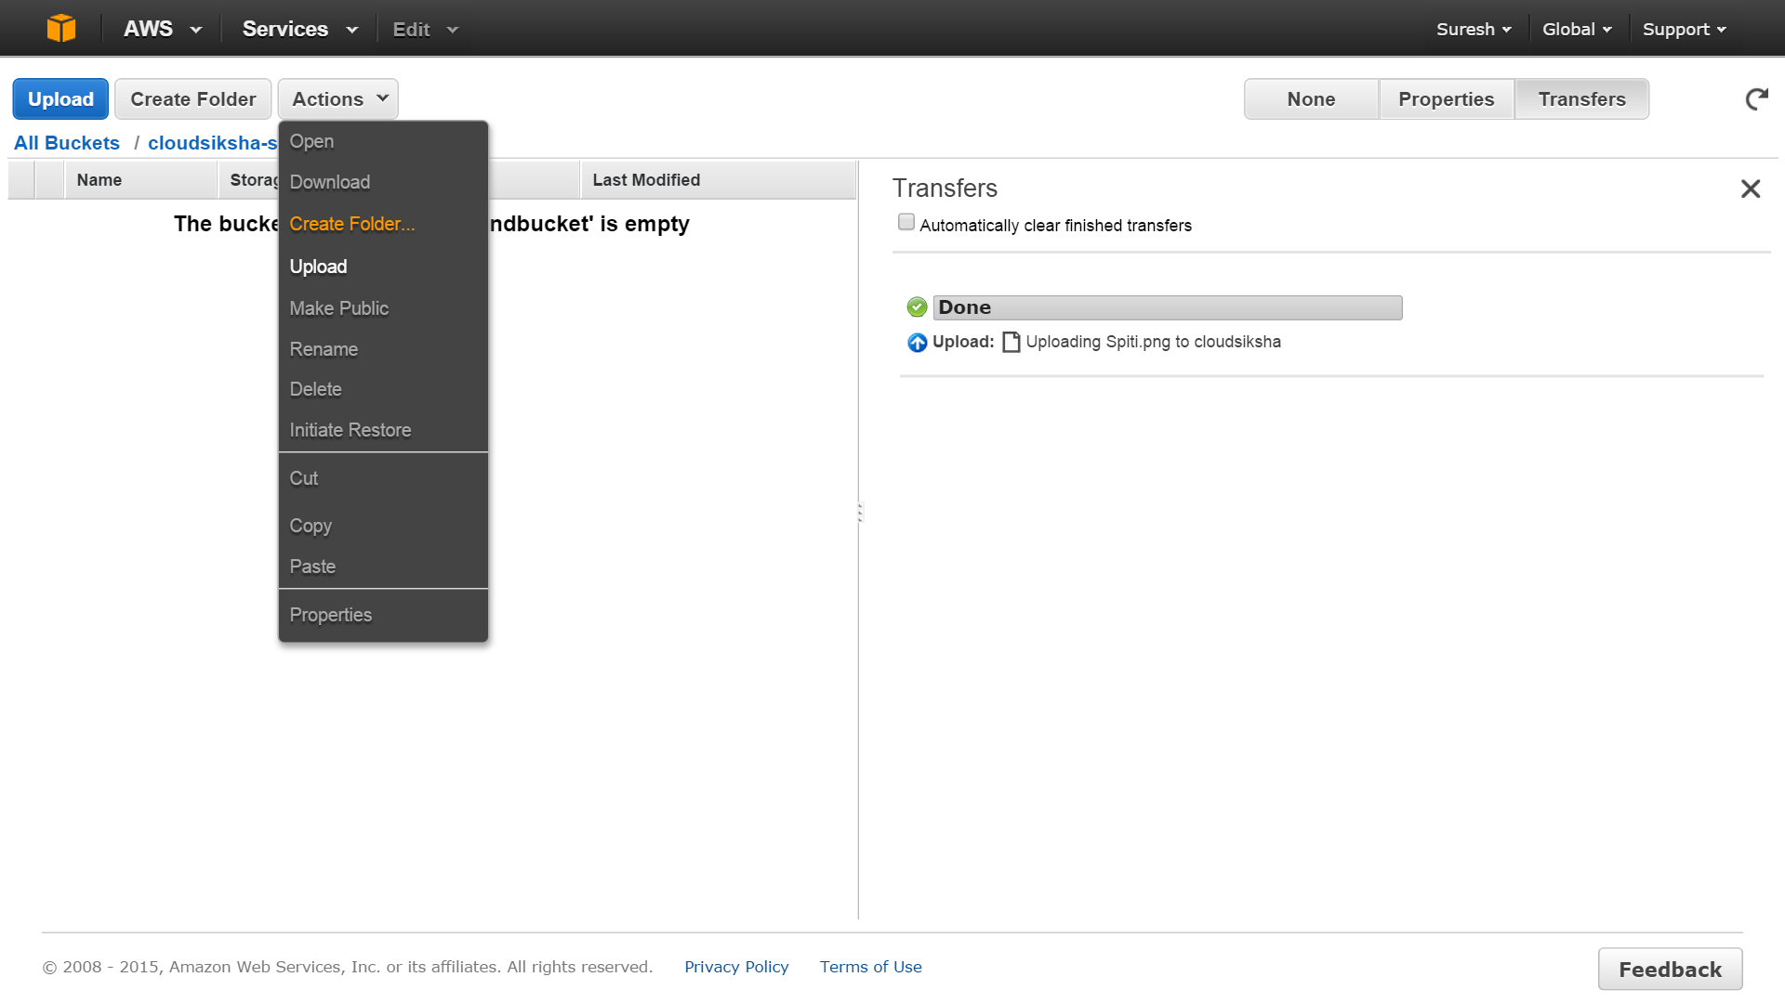

This will create a folder in this bucket.

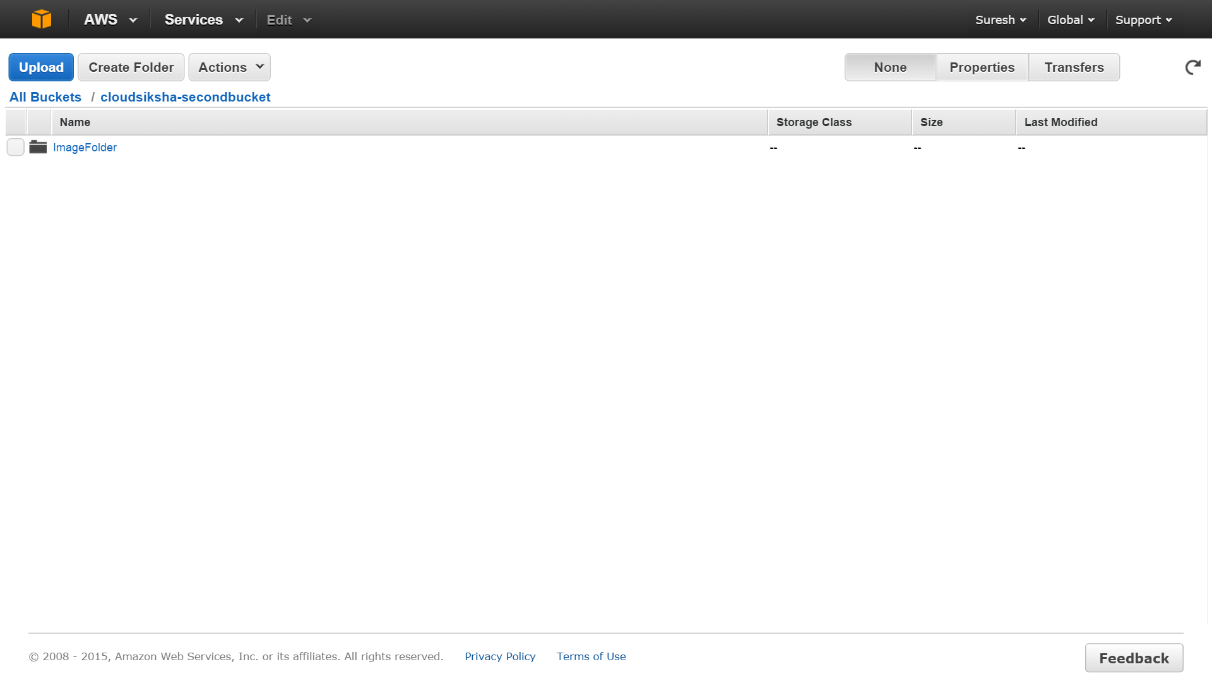

Click on the folder to open it and then upload a file of your choice into the folder. Upload should be done as we did earlier. Now you will have a file inside a folder. You can create multiple folders for your use

### Downloading objects from S3

You can download the objects you have stored in S3.

Click on the first bucket which will take us to the object listing. Choose the object you want to download. Then press ‘Actions’🡪’Download’

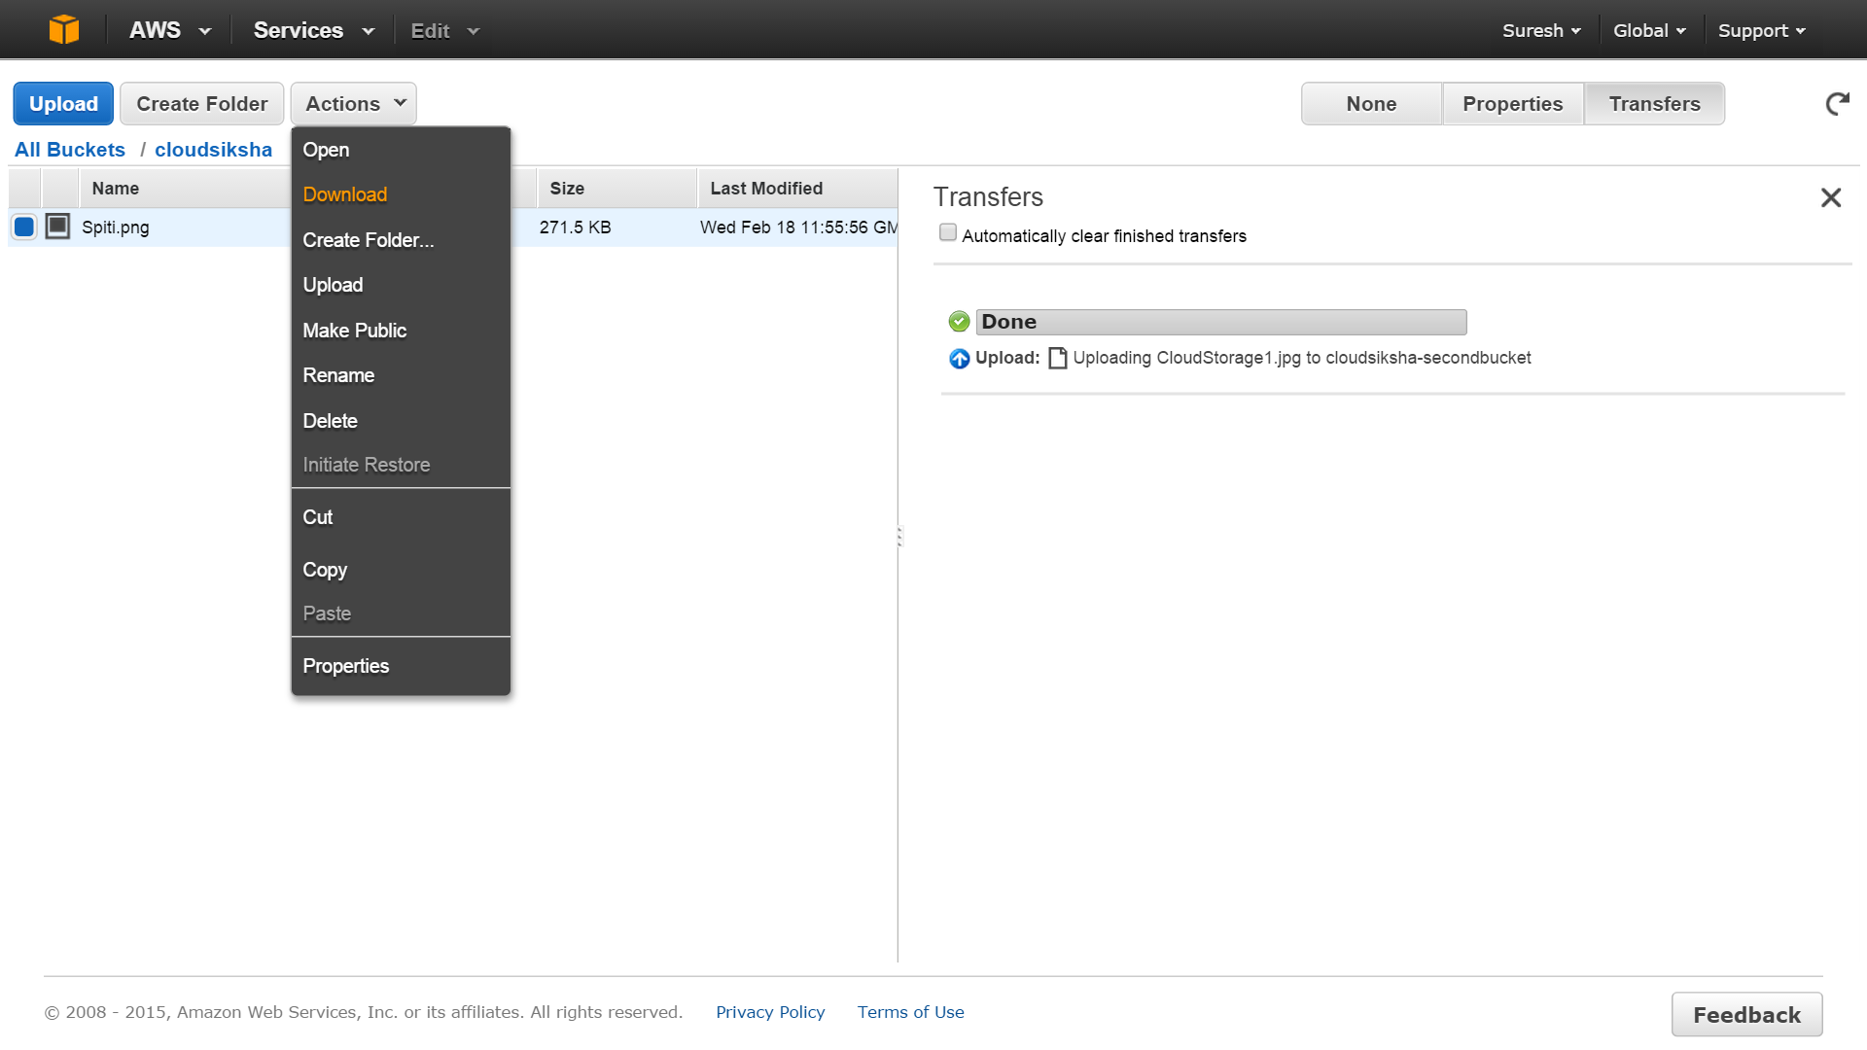

A popup with Download ink will appear. Right click on the link and choose ‘Save Link As..’ to save the file on your computer

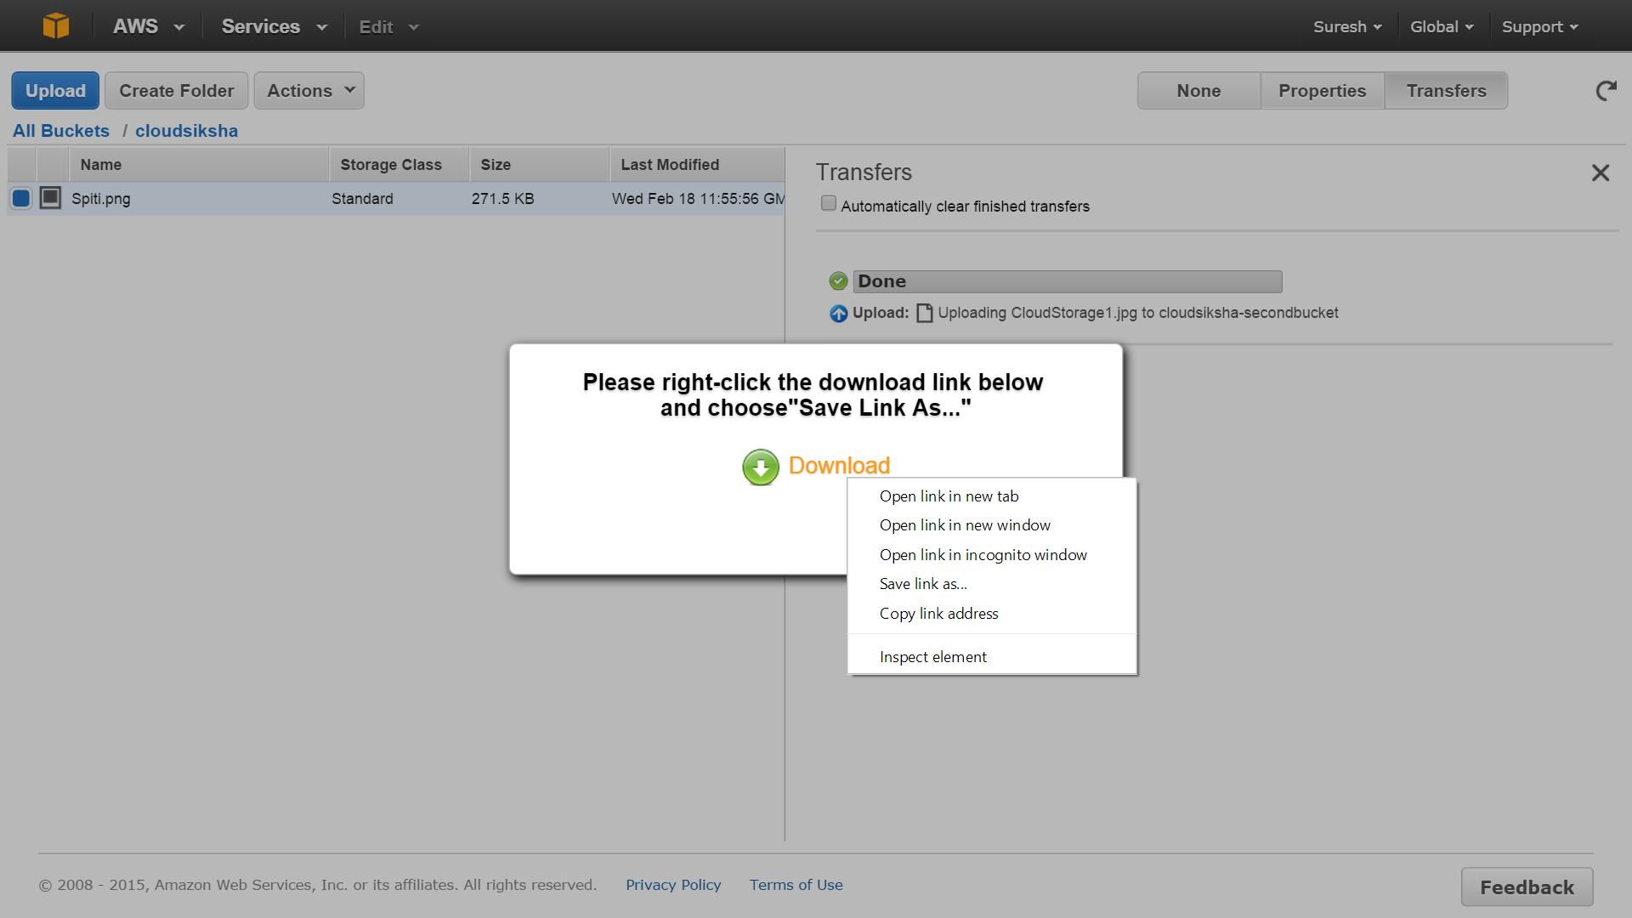

### Setting permissions and viewing objects stored in S3

In case you have uploaded a picture file you can view the file using a browser. For this you need to set the permissions to allow everyone to view the object.

Select the image file you want everyone to view. Then select ‘Actions’🡪’Make Public’. Say ‘Yes’ to the popup message. You will see a message saying ‘Making Public’ Once it is Done the picture can be viewed on a browser.

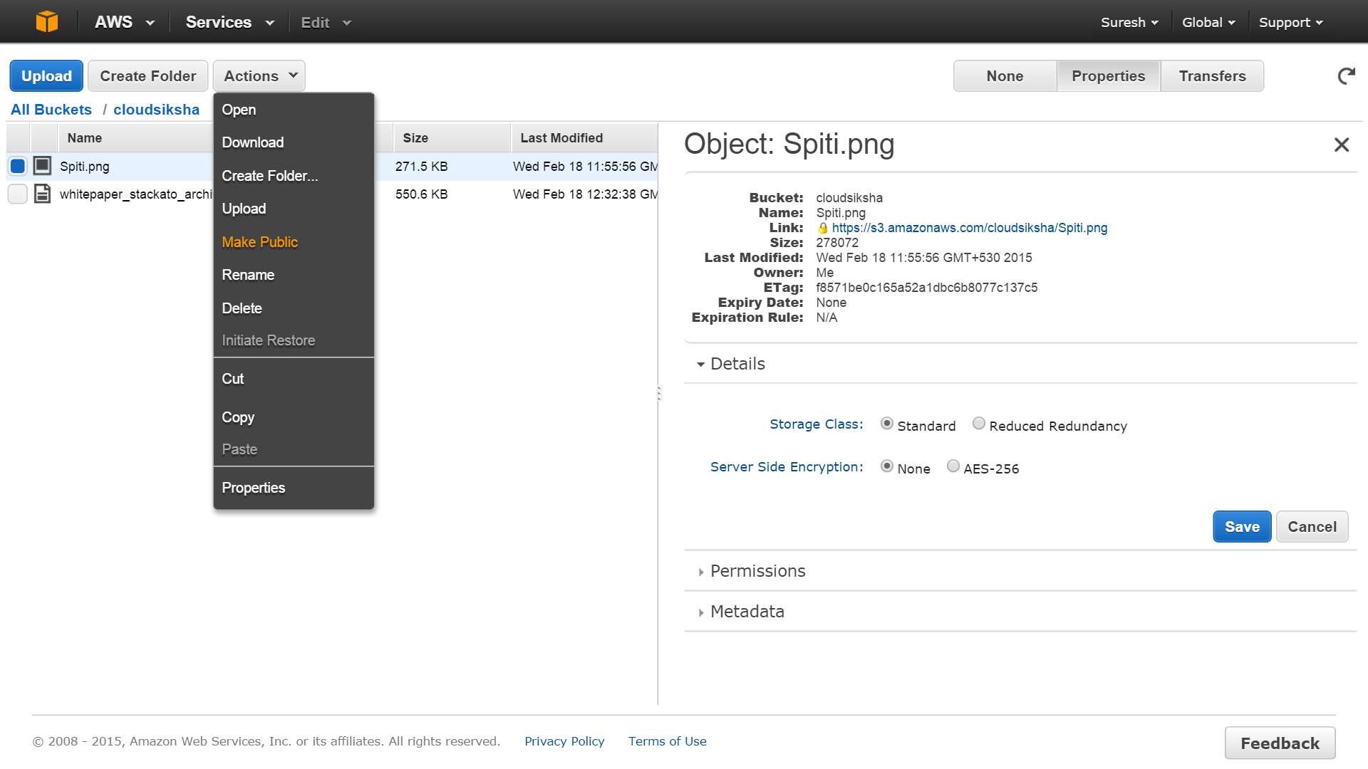

This will ensure that everyone can view this image using a browser and a link that you provide.

On the same screen, keeping the object selected, click on ‘Properties’. You will get a web link for your object.

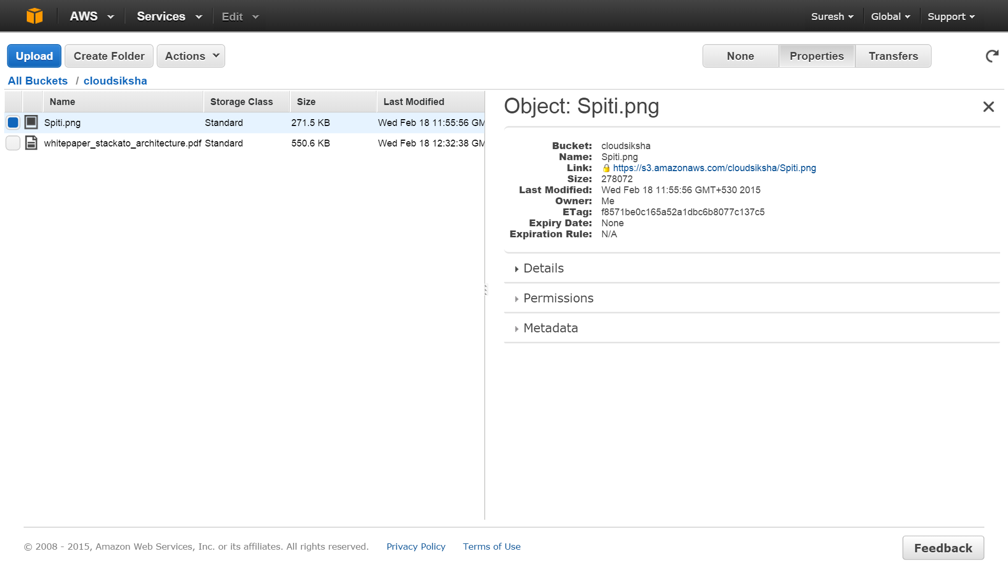

Cut and paste this link in the browser of your choice or just on that link. You will be able to view the picture you had uploaded.

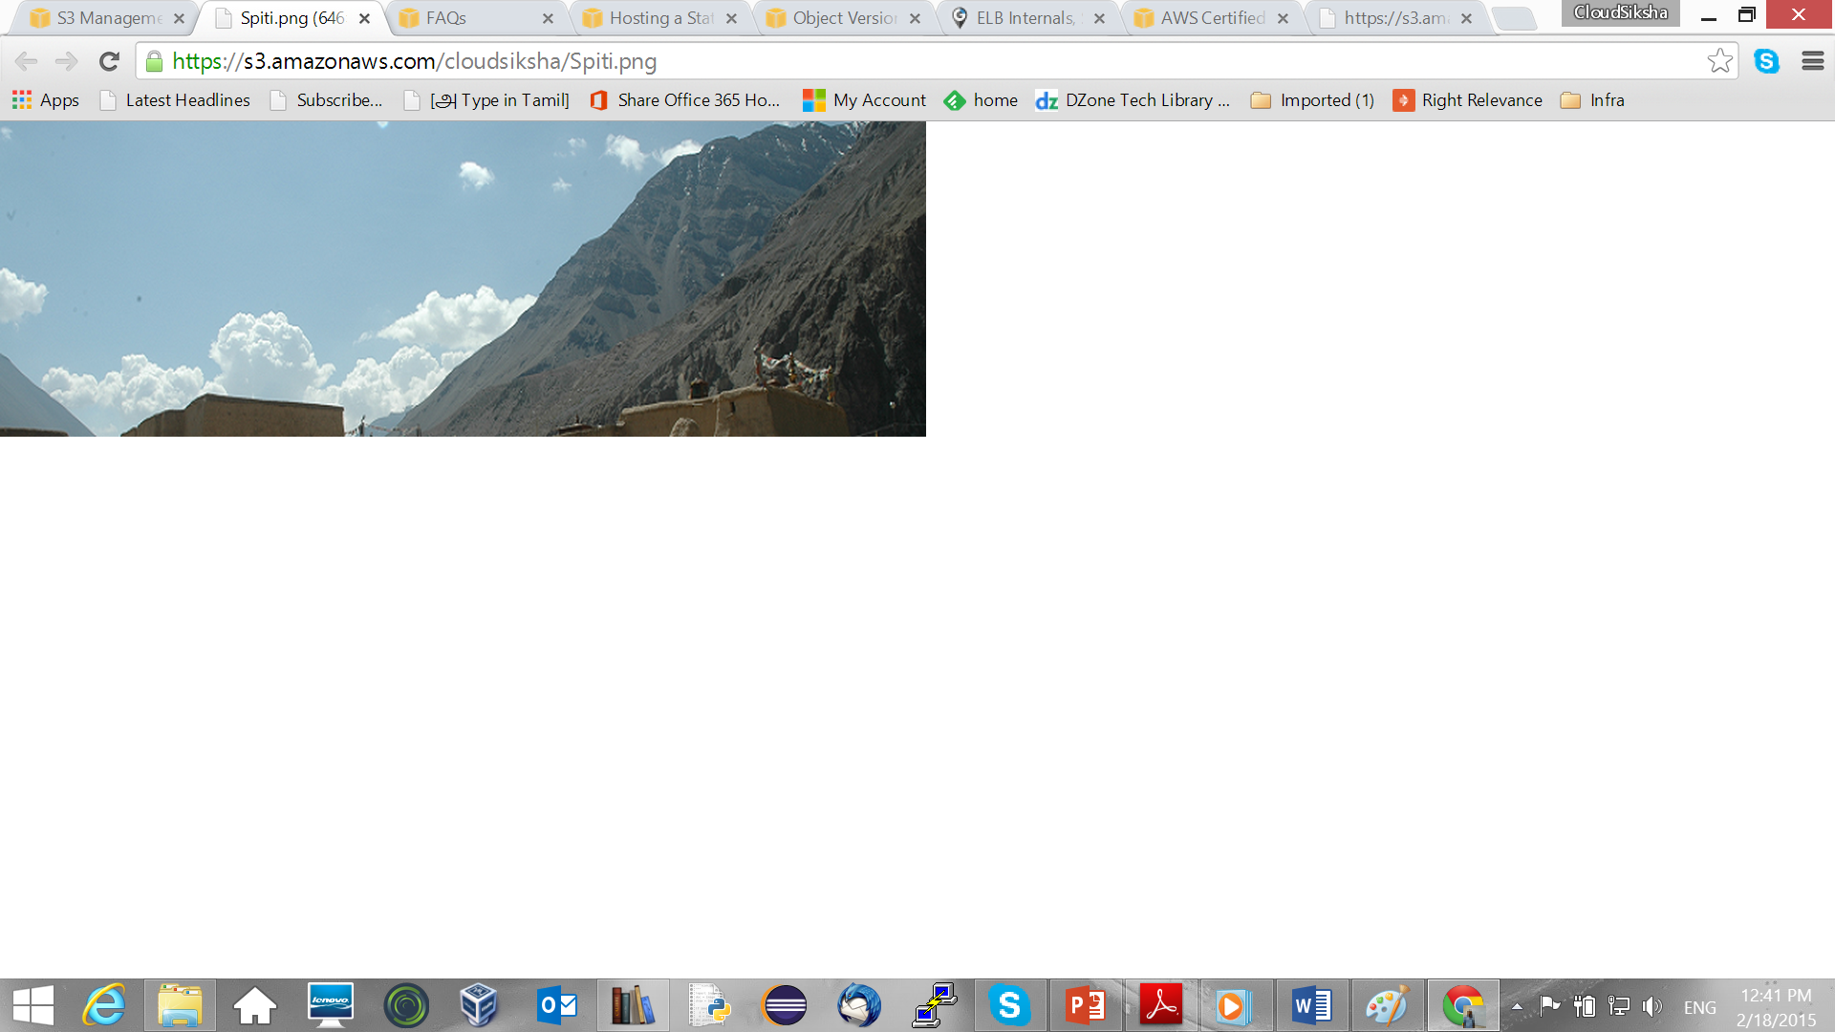

You can do a similar thing with pdf file. If you upload a pdf file, you can make it public and the pdf file will open in a browser.

### Removing permissions

You can remove the permissions that you had granted earlier (making the object public) by selecting the object, select Properties, select Permissions and uncheck Opern / Download permissions against Everyone. Click ‘Save’. You will no longer be able to view the file using the browser.

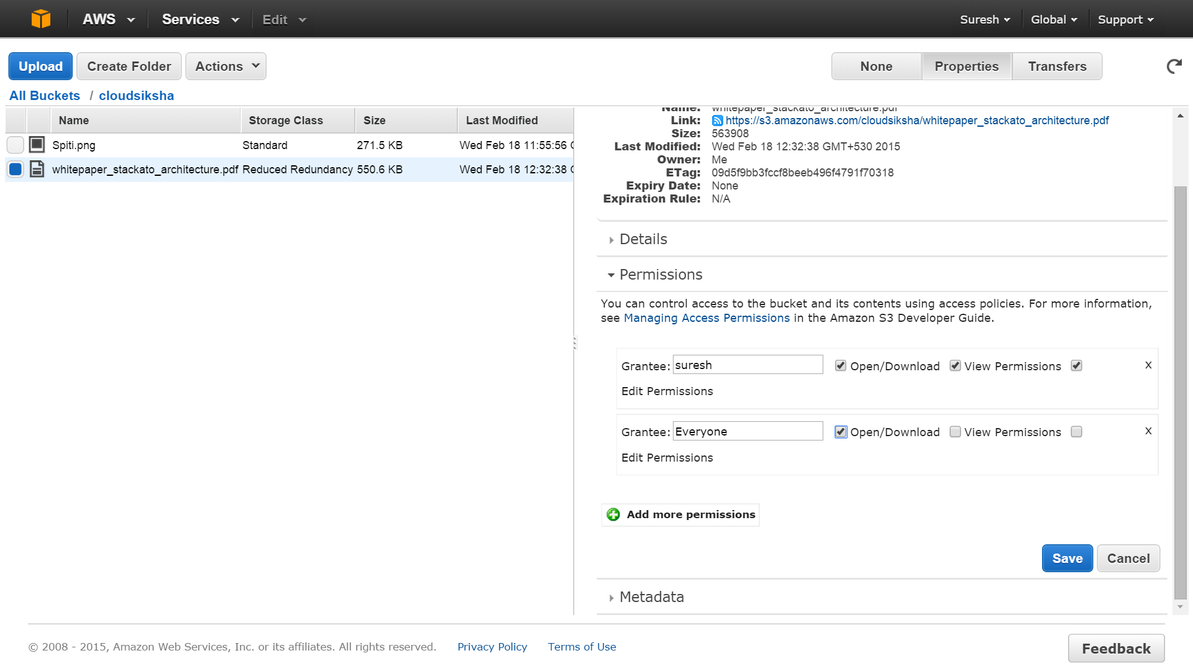

### Hosting a Static Website

S3 buckets can be used to host static websites. Go to the ‘All Buckets’ screen. Select the bucket you want to host the static website and click on ‘Properties’. In the right side of the screen you will see ‘Static Website Hosting’. Expand it and click “Enable Website Hosting’ and in Index Document type ‘index.html’. Scroll down and press ‘Save’

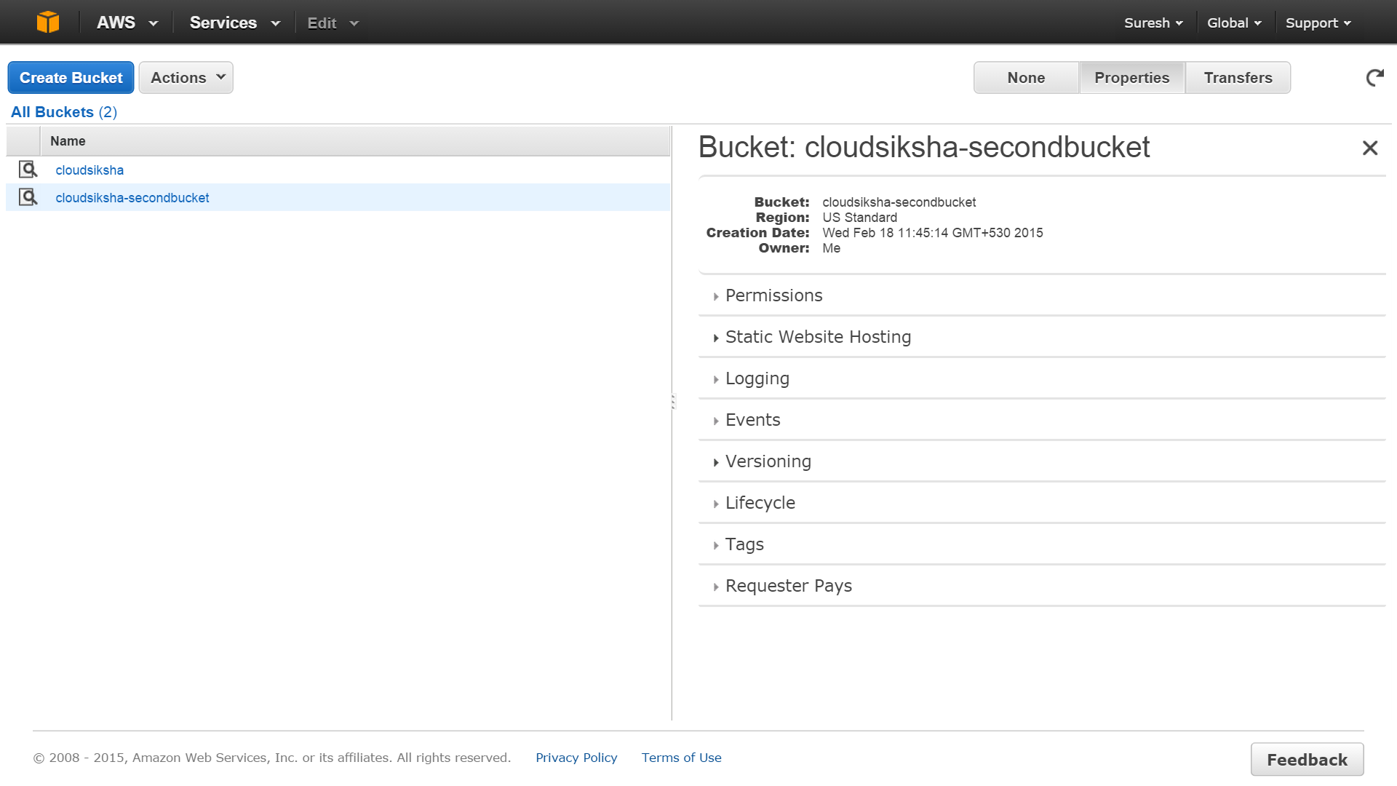

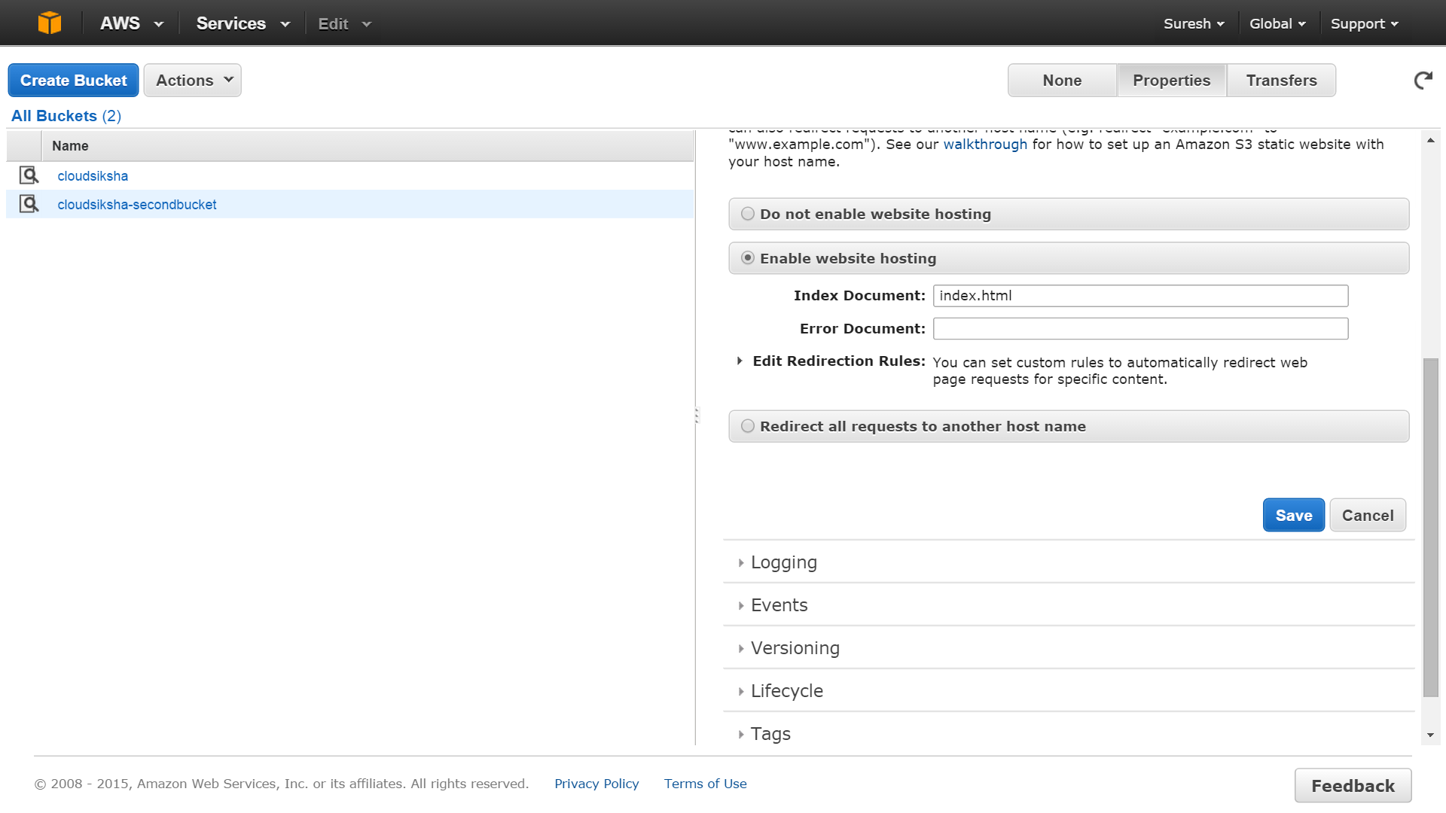

Prepare an index.html which has a minimum of the text given below and upload it into the bucked which will the static website.

<!DOCTYPE html>

<html>

<head>

<title>*Any Text You want* </title>

</head>

<body>

<h1> *Any Text you want* </h1>

<img src=”*Link to image stored in S3*” alt="*Text about the image*”>

</body>

</html>

</html>

Once you have uploaded the index file, ensure you make it public. (Else you will get an error). After making index.html public, come back to the ‘All Buckets’ scree and select the bucket which hosts the static website. Click on Properties. Under ‘Static Website Hosting’ you will see an Endpoint. This is the URL for your website. Click on it to view your website.

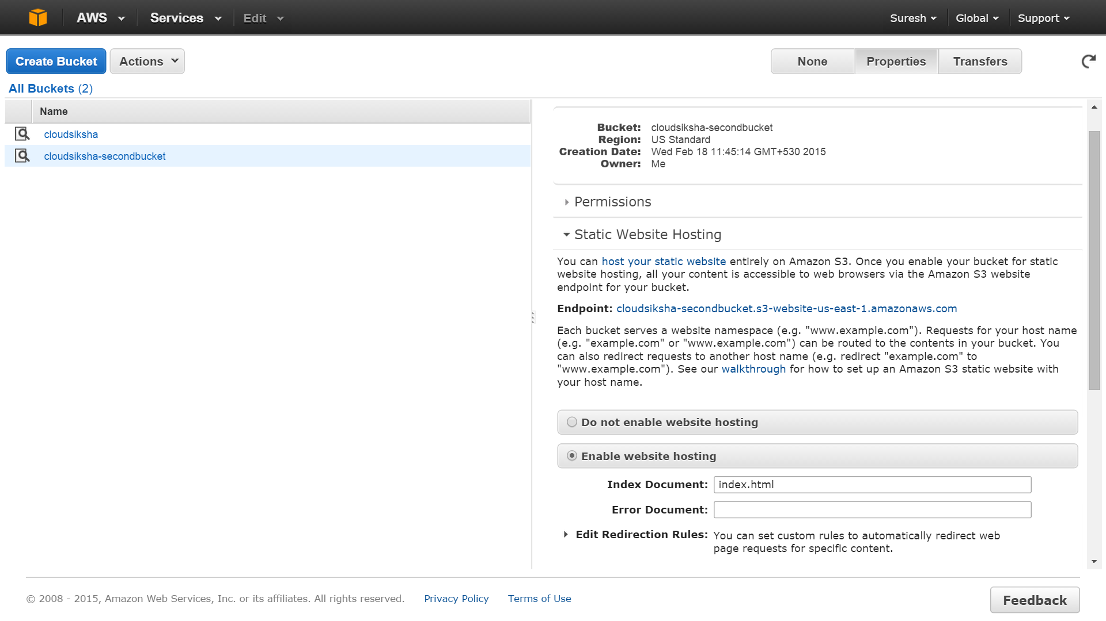

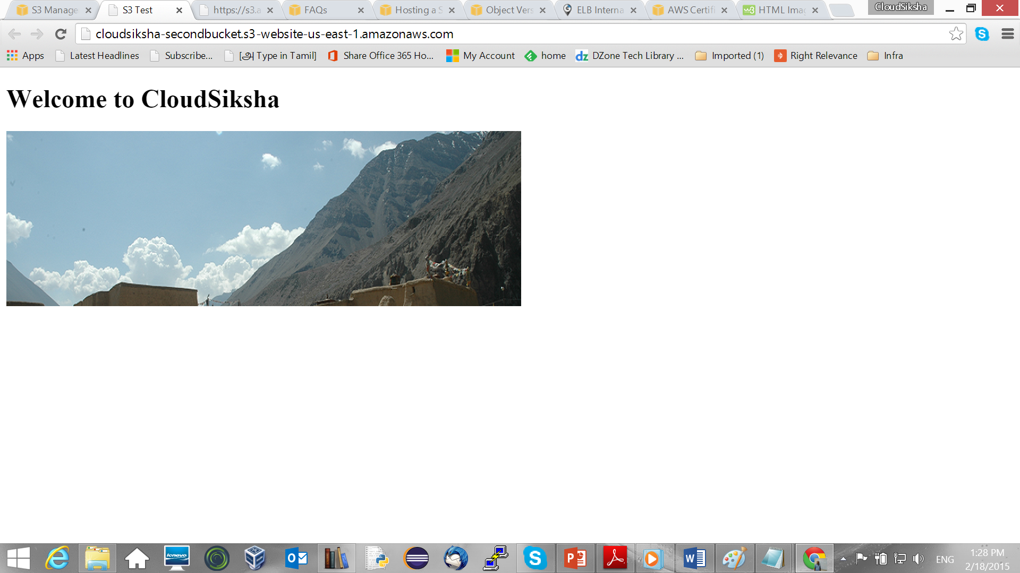

### Storing with Reduced Redundancy or Infrequent Access

If you want your object to be stored with Reduced Redundany or Standard Infrequent Access, select the object and click on ‘Properties’. Under ‘Properties’ click on ‘Details’ Select Reduced Redundancy or Standard Infrequent Access. Click on ‘Save’ after you have done selecting. Your object will now be stored with reduced redundancy and you will be billed accordingly.

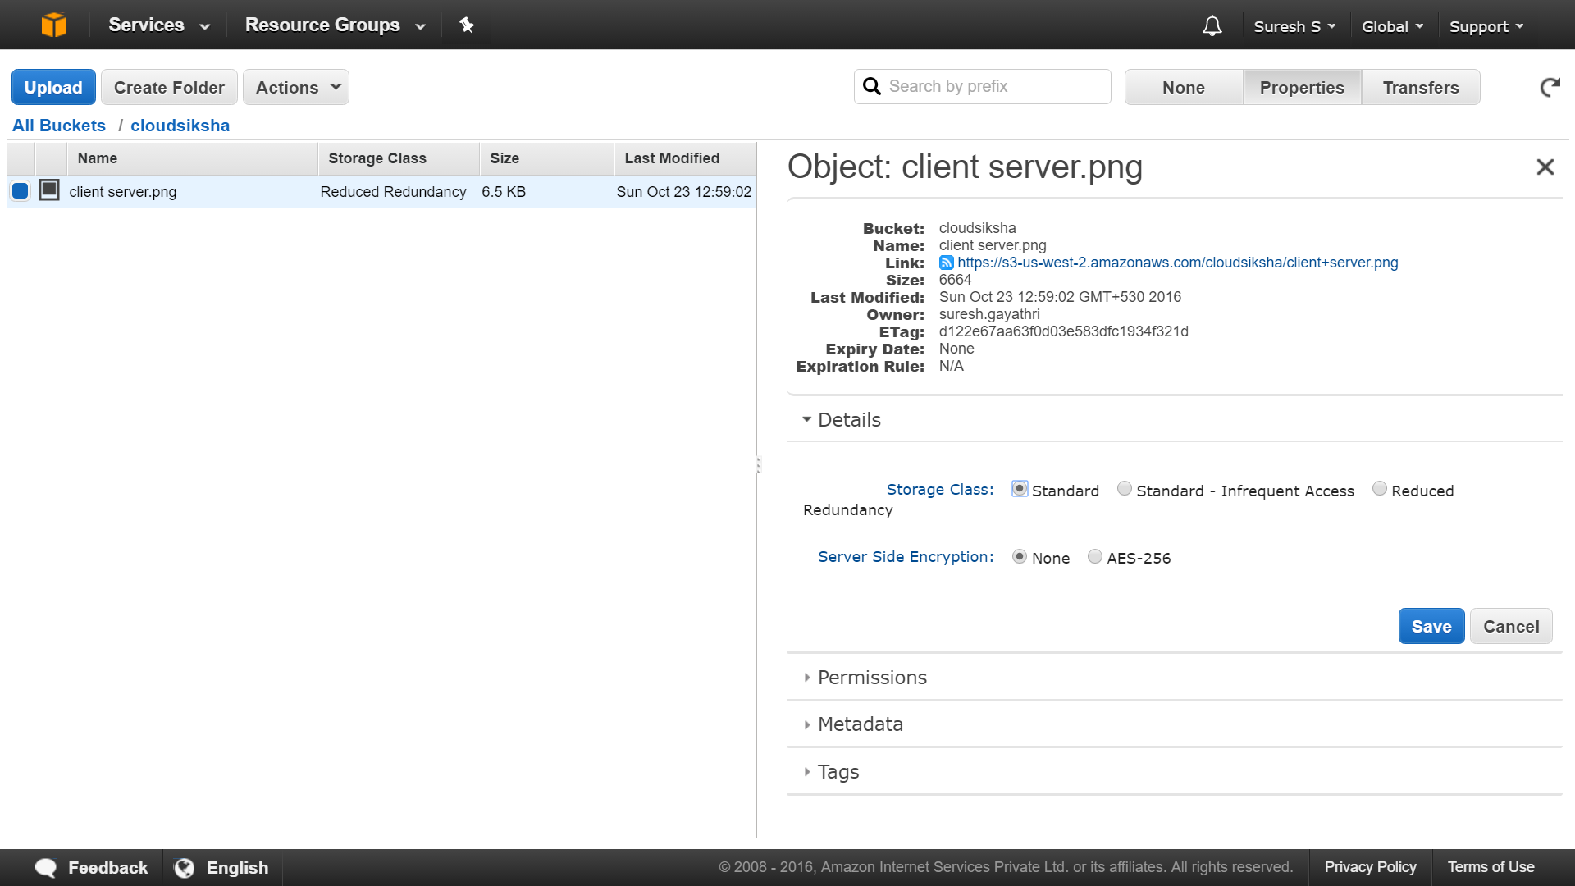

Using the same Details screen you can set the Encryption for the object.

### Deleting Objects

To delete an object, select the object you want to delete. Then select ‘Actions’🡪’Delete’ This will delete the object.

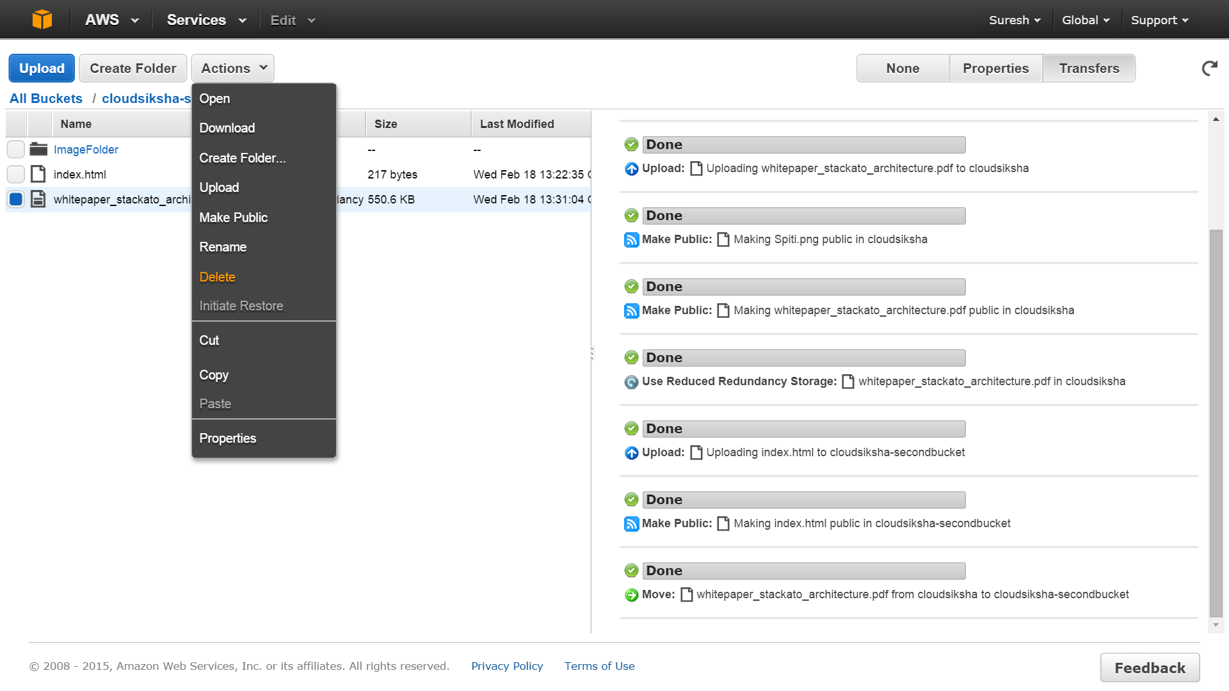

You can also copy objects from one bucket to another. Remember that if your buckets are in different regions and your object size is large, you may incur a significant network cost

# Exercise 6

## Building a VPC

This exercise will enable you to build your own private Virtual Public Cloud. From 2013 onwards, all EC2 instances are launched in one VPC. Amazon provides a default VPC for your account. For security purposes we must build our own VPCs. This exercise will take you through VPC creation, Internet Gateway Creation, Assigning IP Address, Changing Routing Tables and creating a NAT.

### Creating a VPC

Note: Before starting this exercise, delete all instance for those instances would have been launched in default VPC. We will not launch instances in our own non-default VPC

From AWS Console, select ‘VPC’ under Networking

Choose ‘Your VPCs’ from the left side menu

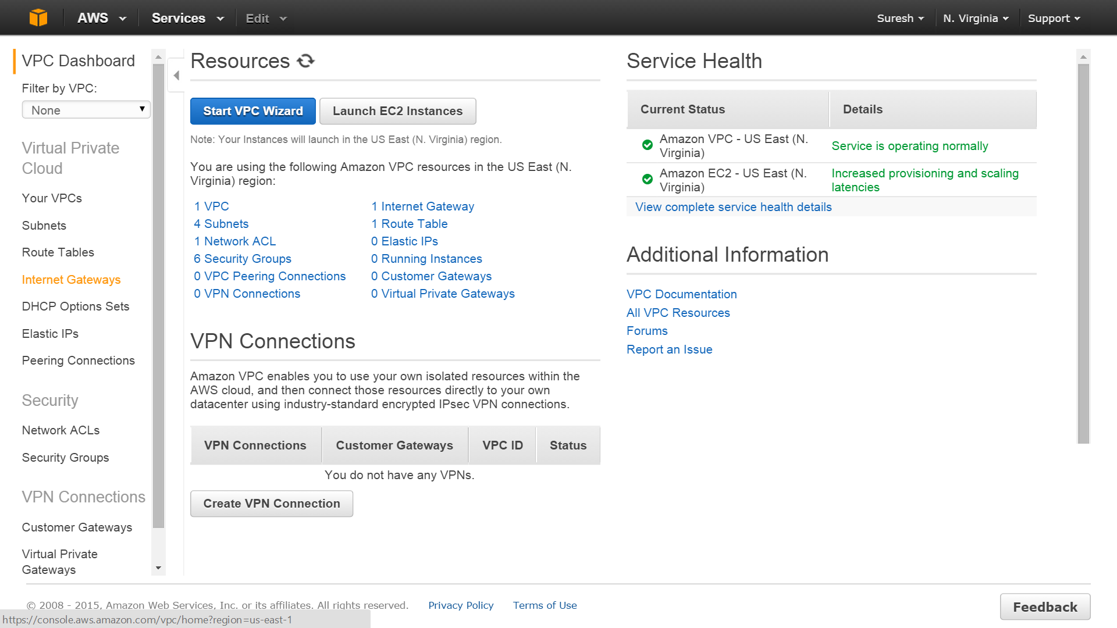

You will see the VPC screen with a default VPC. (NEVER delete the default VPC.) Click on ‘Create VPC’

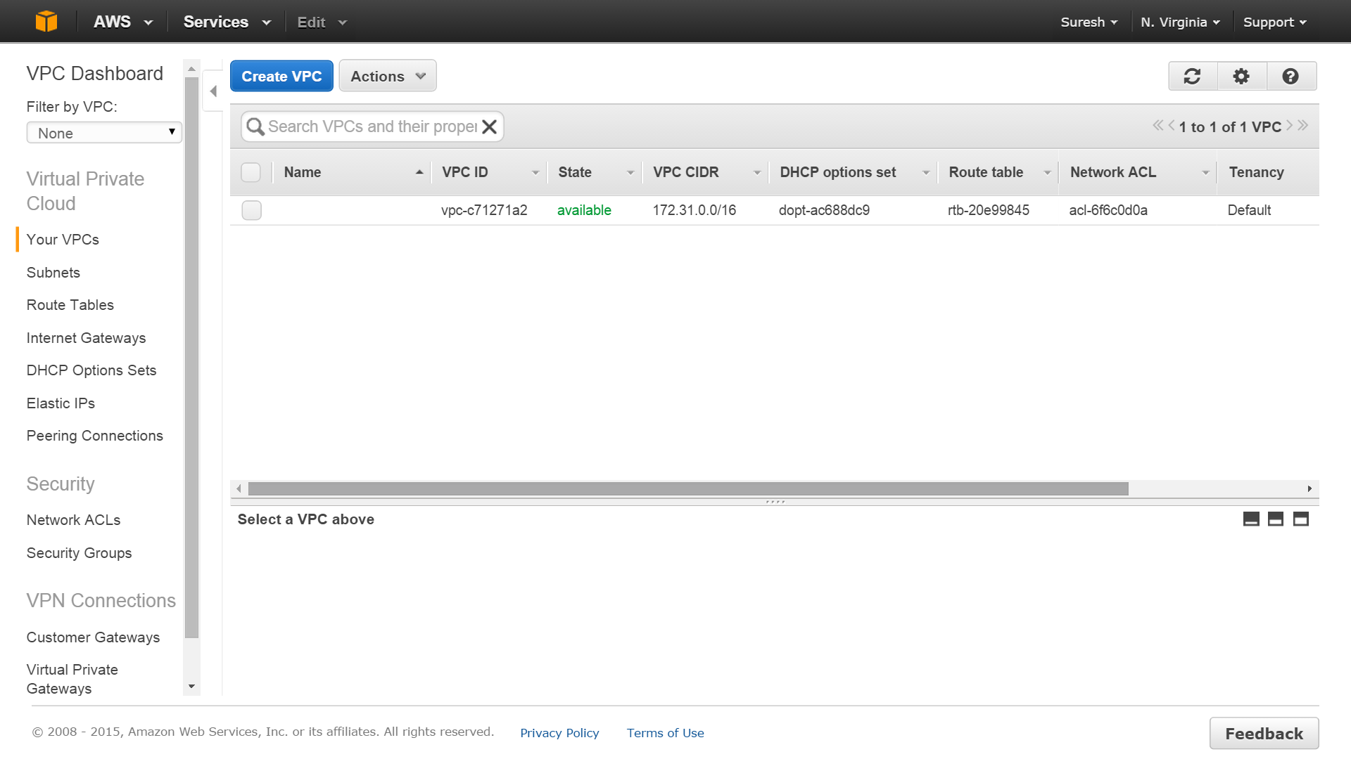

Enter a name for your VPC, Input 10.0.0.0/16 as the CIDR and leave Tenancy as Default and click Create

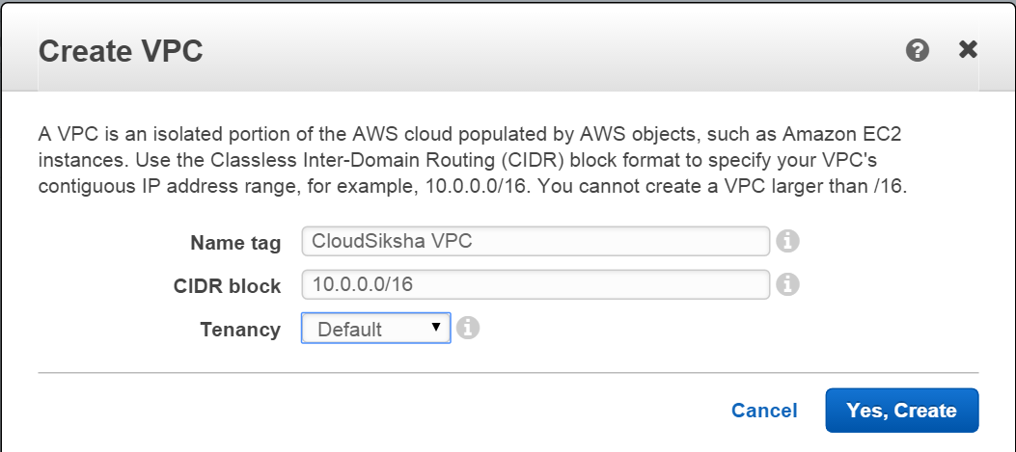

You have now created a VPC and it is available for your use

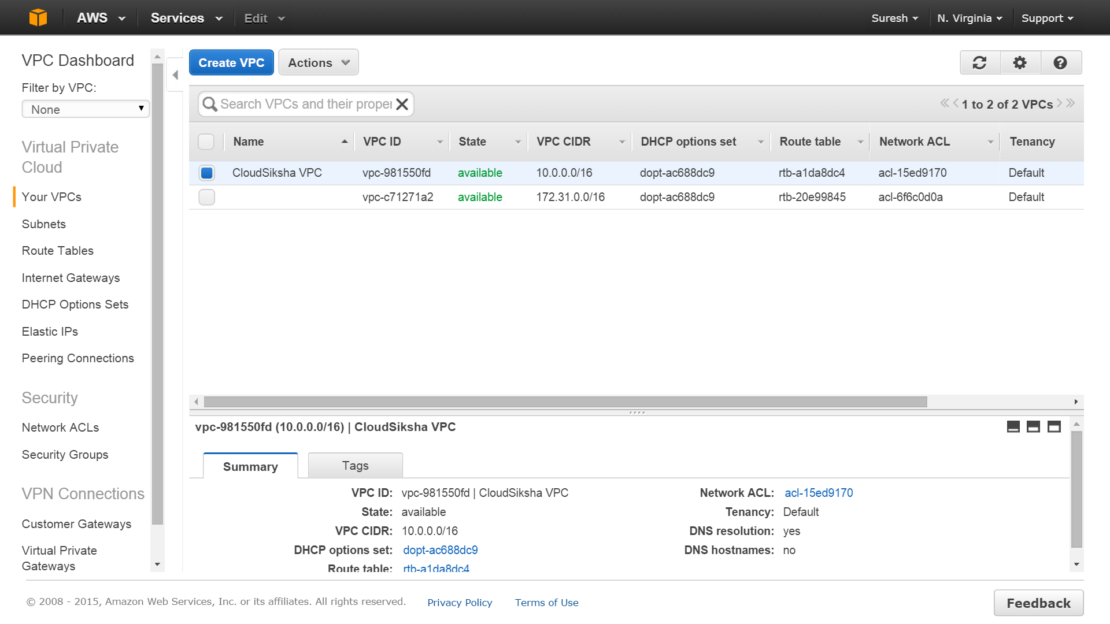

### Creating subnets

We will now create two subnets. We will keep one subnet private and make another subnet public. We will launch one instance in each subnet in order to explain various VPC concepts

In the VPC Dashboard, select ‘Subnets’ from the left side menu. You will be taken to the Subnets Dashboard. Observe that there are default subnets existing. DO NOT DELETE THE DEFAULT SUBNETS. Click on ‘Create Subnet’

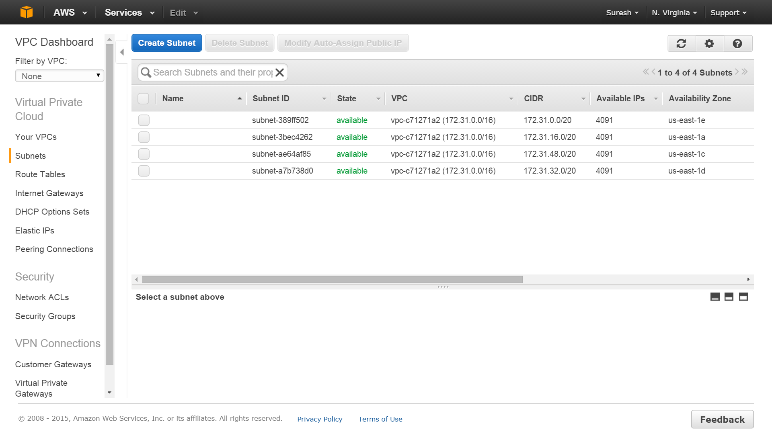

Provide a name for your subnet

Choose the VPC we just created from the drop down.

We will give a name for the subnet which we can remember easily. You can give any name you want but it is a good practice to give a name that lets us identify the subnet easily. You can probably name it with the IP address range of the subnet itself.

The CIDR range must be a subset of the 10.0.0.0/16. We will use 10.0.1.0/24 for one subnet and 10.0.2.0/24 for the other subnet. We will make the first subnet public. We will keep the second subnet private.

We can have each subnet in a different zone. So choose one zone for first subnet and a different zone for the second subnet.

After inputting / choosing values, click ‘Yes, Create’

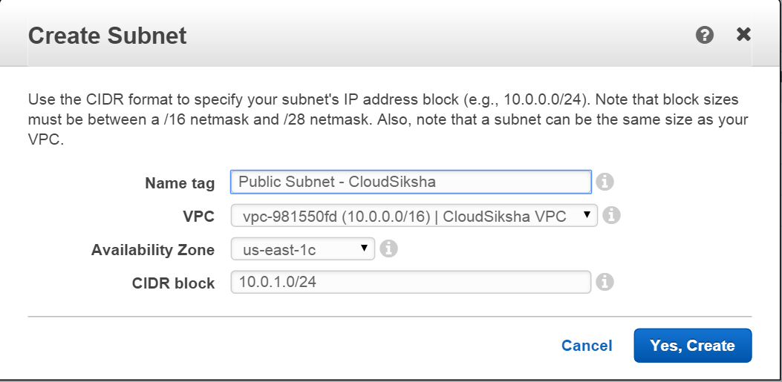

We will now create a second subnet in the same VPC. Here the CIDR range will be 10.0.2.0/24 and we choose a different region for this subnet. Press ‘Yes,Create’

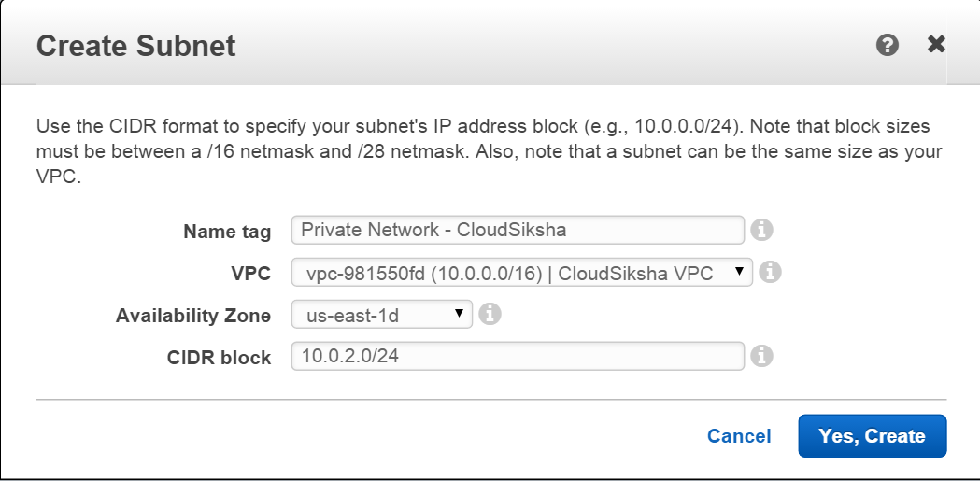

We have now created two subnets

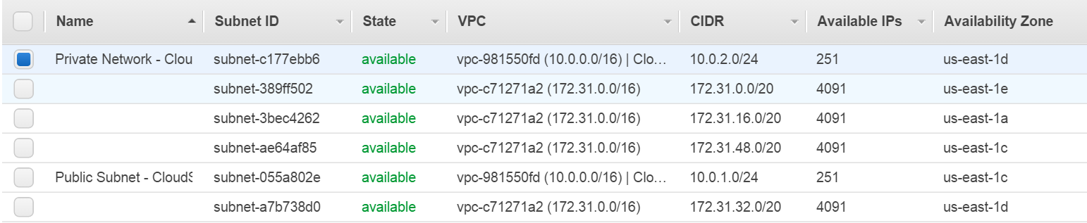

### Creating Internet Gateway

In order to access an instance from internet need to create an Internet Gateway. An instance in a subnet must be connected to this Internet Gateway via an Elastic IP address for the external world to reach the instance.

On the left side menu of the VPC Dashboard, click on Internet Gateways. You will be taken to the Internet Gateways screen. You will see a default gateway. NEVER DELETE THE DEFAULT GATEWAY

Press on ‘Create Internet Gateway’

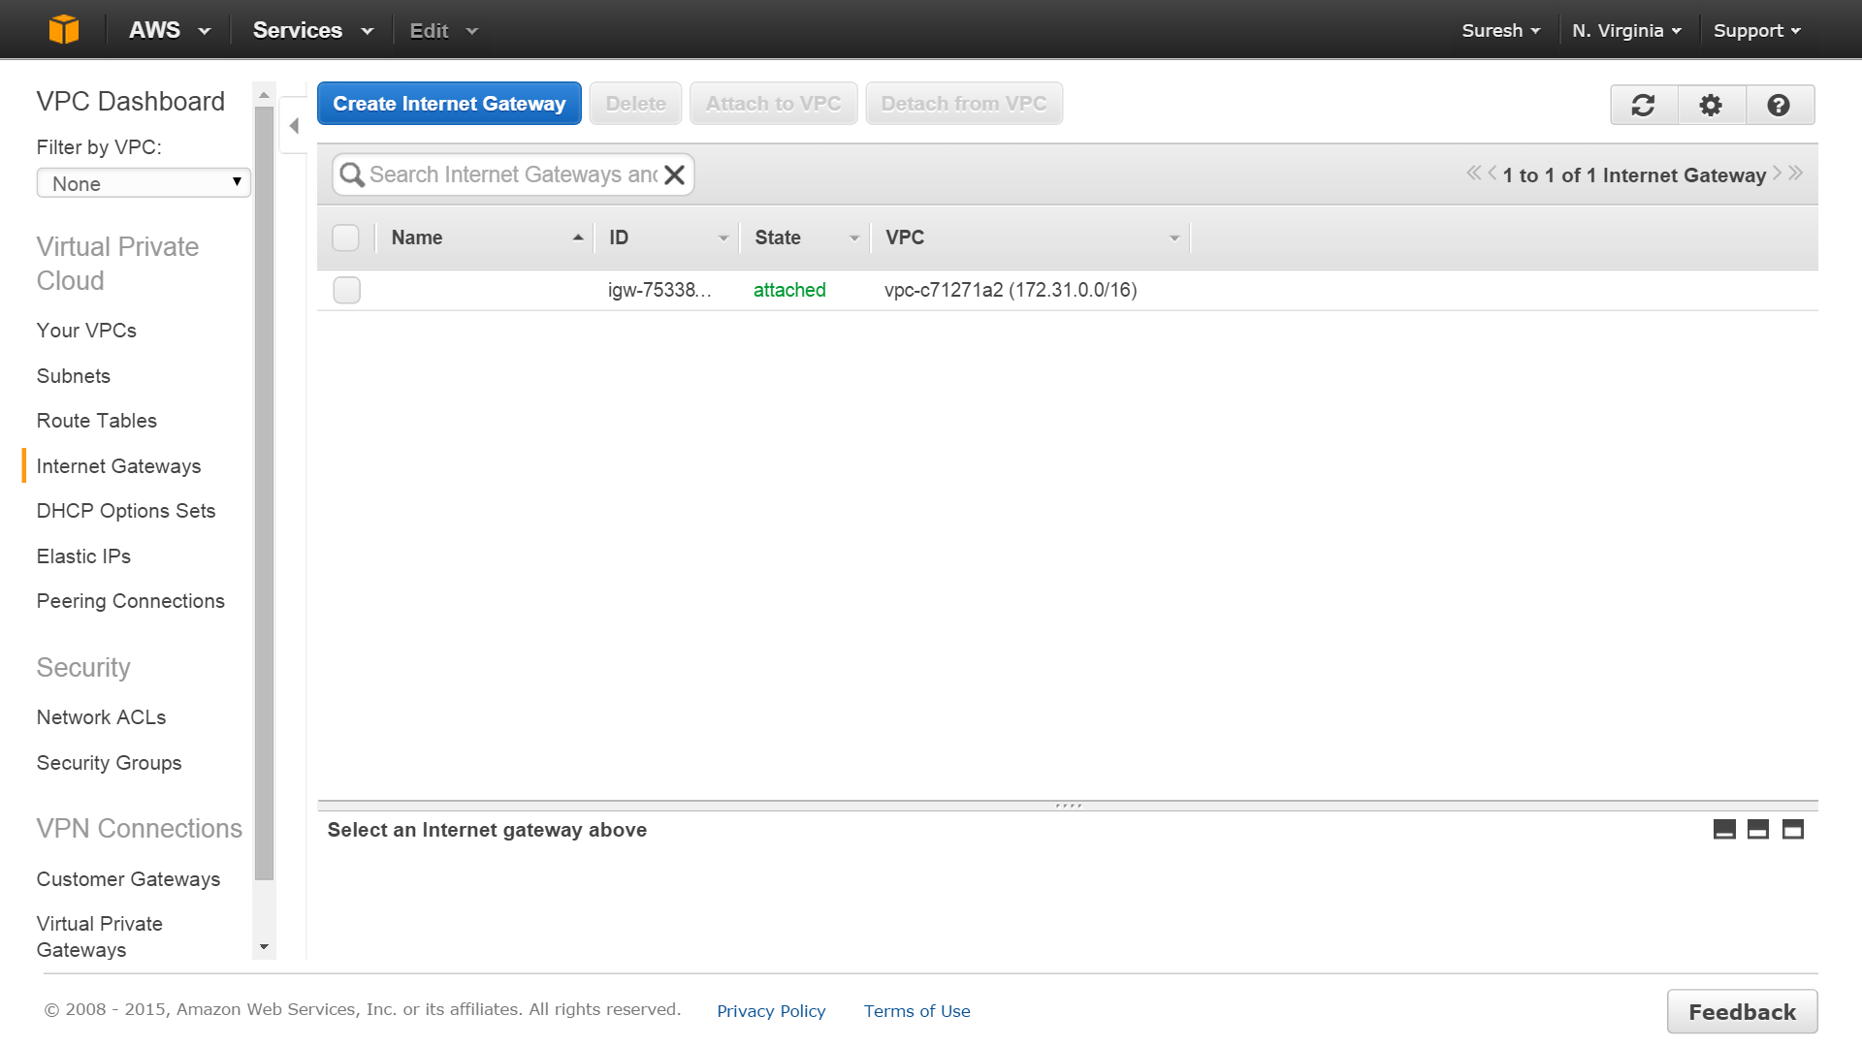

The Internet Gateway only needs a name as input. Input a name of your choice and press ‘Create’

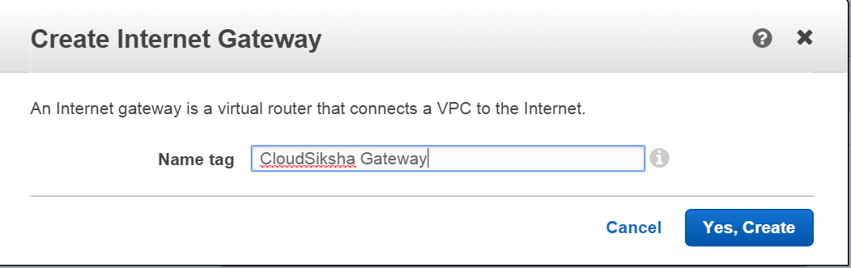

Your Internet Gateway is ready but is not attached to any VPC (The state is ‘detached’) Select your Internet Gateway and press on ‘Attach to VPC’

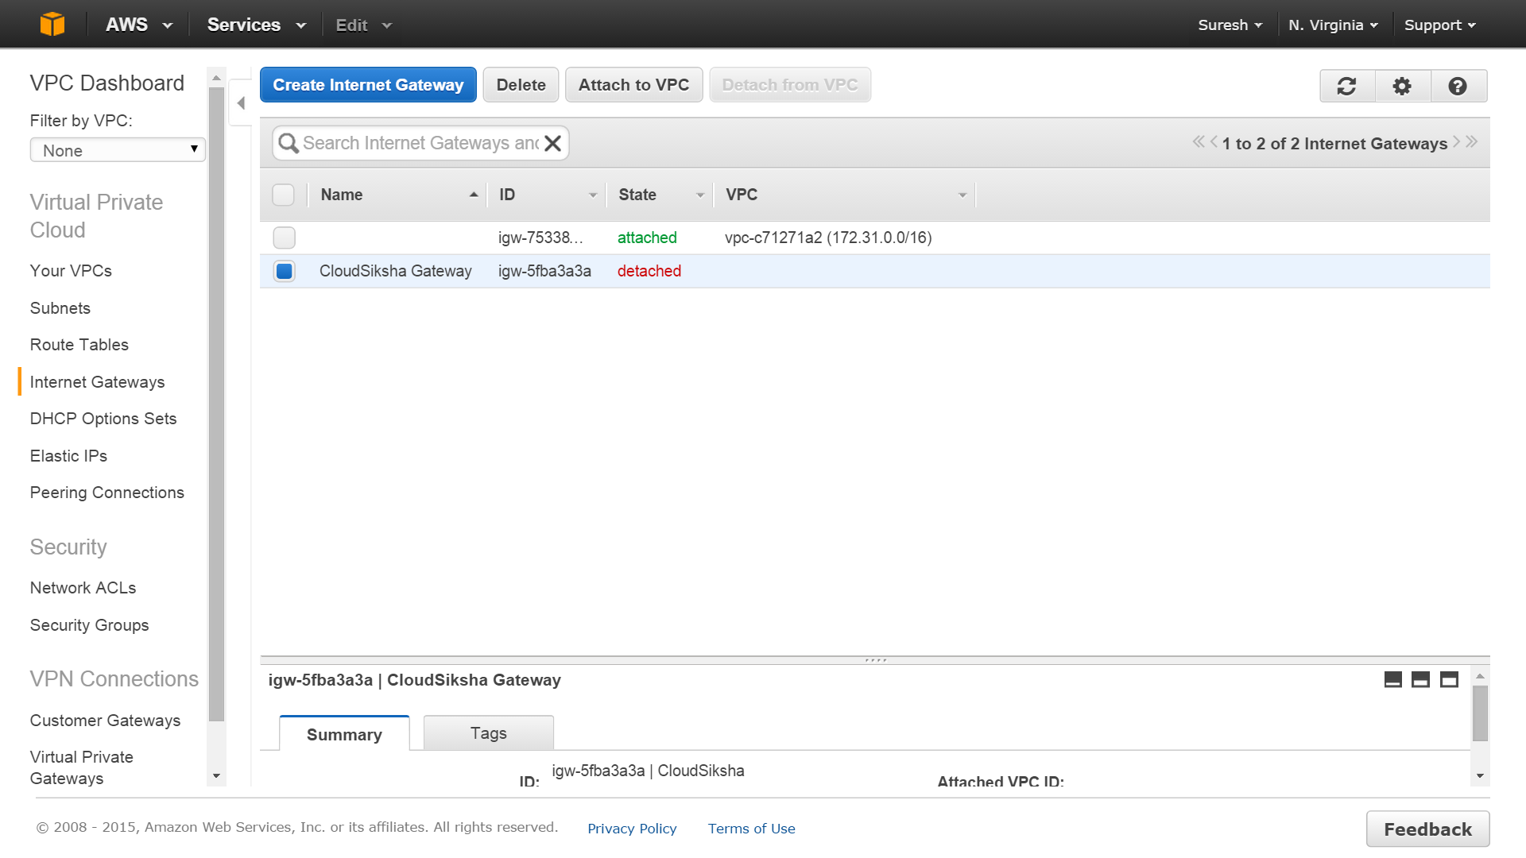

Select the VPC that you have created and press ‘Yes, Attach’

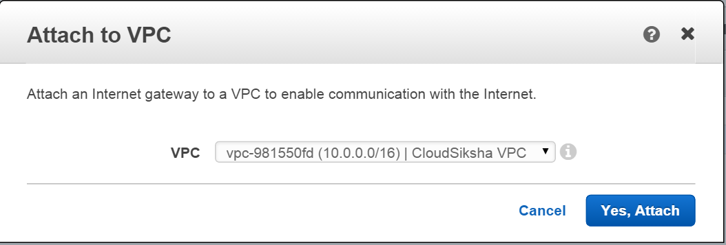

Now the Internet Gateway is attached to the VPC you have created

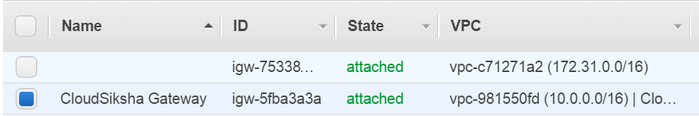

### Creating Routing Table

We will now create a routing table and use it to attach our public instance to the Internet Gateway. Routing table is what provides the connection between the subnet and the internet gateway. Without a routing table an instance cannot become a public instance.

On the VPC Dashboard, click on Route Table. You will see some default routes. One of them will be the default table for the VPC you created. The rule in the table allows for communication between private subnets within the same VPC. DO NOT DELETE THE DEFAULT ROUTING TABLES.

Click on ‘Create Route Table’

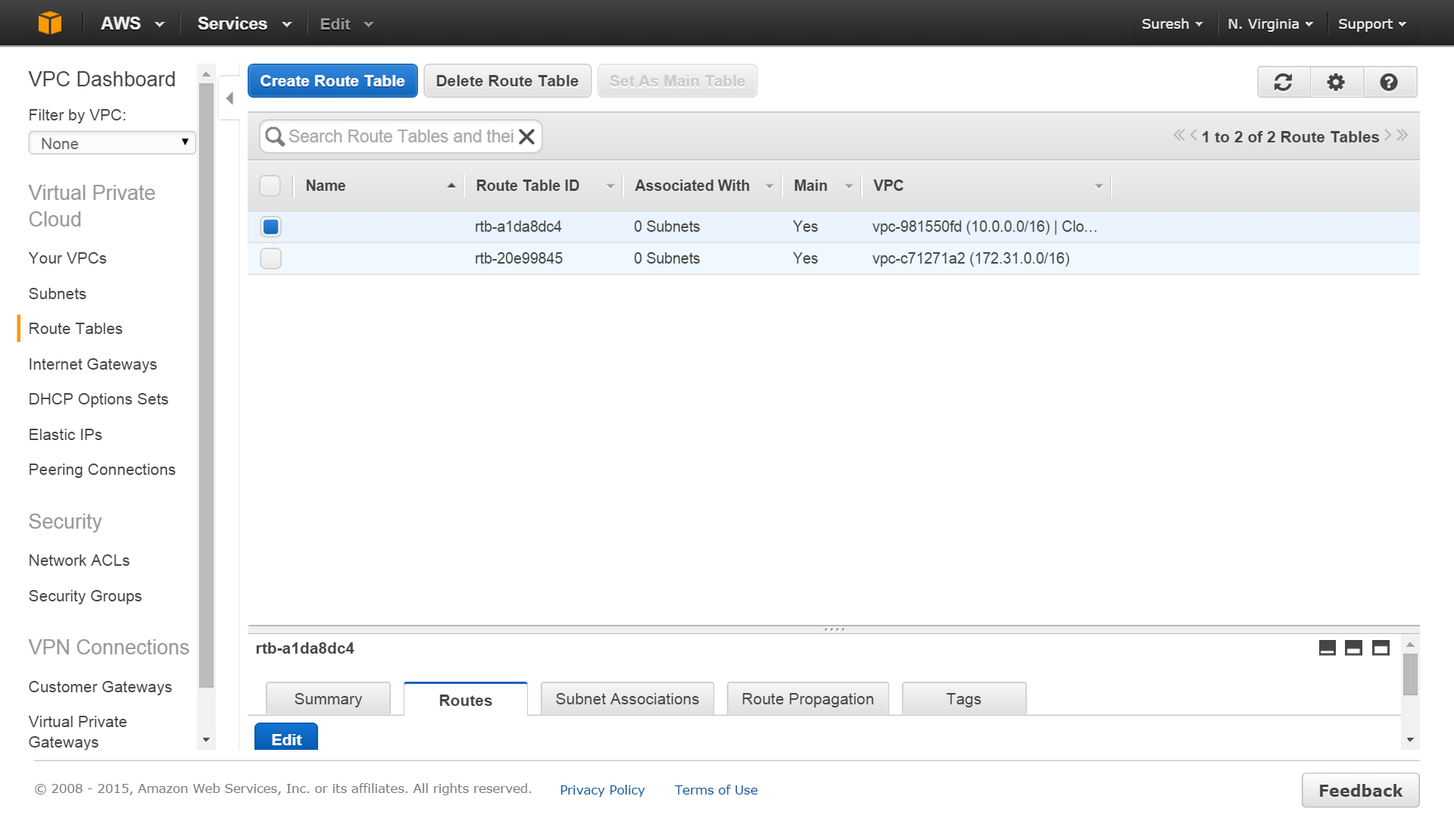

Provide a name for the route table and select the VPC you have created. Press ‘Create’

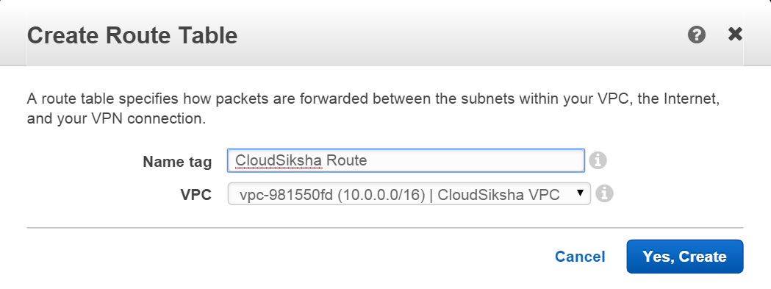

Select your Route Table and in the bottom menu go to the ‘Routes’ tab and click ‘Edit’

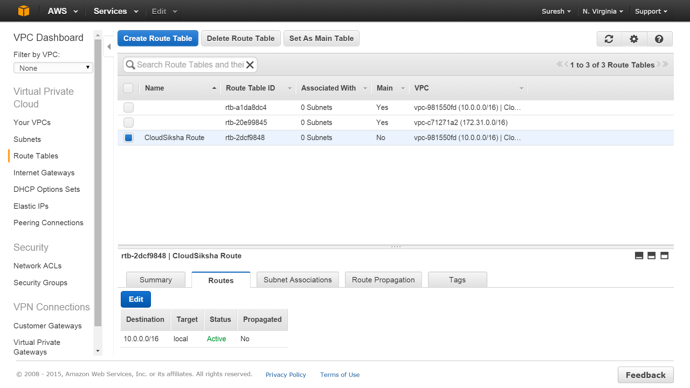

Click on “Add Route’ and Enter 0.0.0.0/0 in Destination. Click on the target area and you will see a list of gateways created, in our case there will be only one. Select this gateway. Then press Save. Now you have a new route which goes through the Internet Gateway.

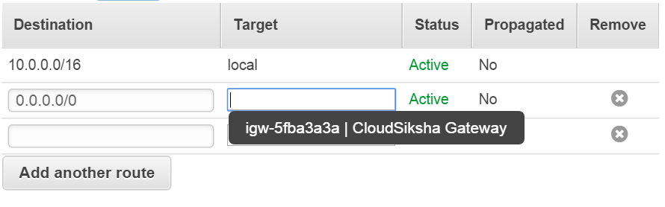

Now the Route Table is ready

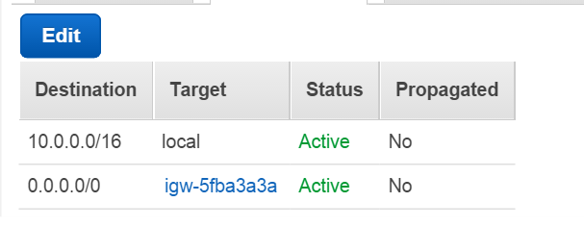

### Launching instances into subnets

We will now launch one instance each into each of the subnets. Launching instance goes through the same process which you learnt in Exercise 1. The only difference is that we will launch it into our VPC and into the subnet of our choice. This is done in the ‘Configure Instance Details’ screen.

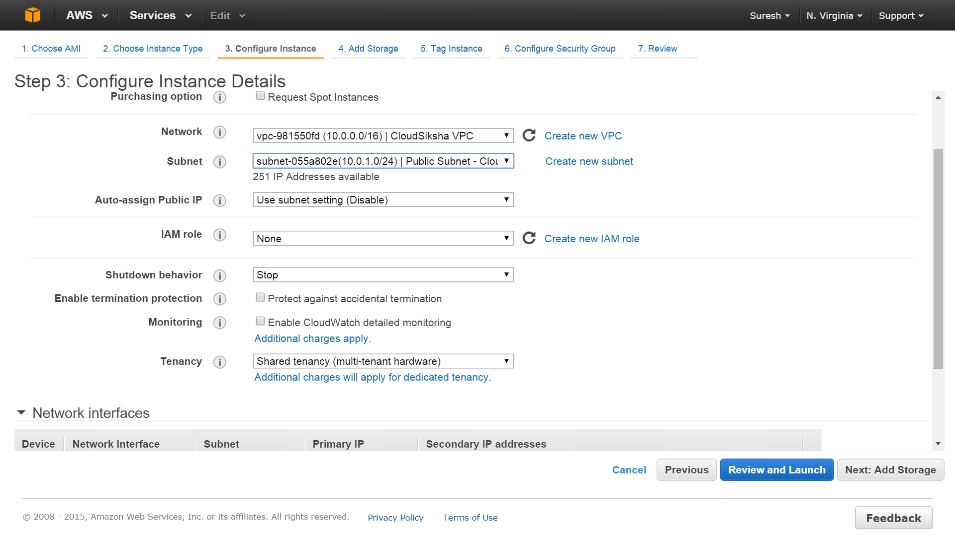

You need to launch both instances in the same VPC. Launch one instance into subnet 1 and another in subnet 2

You will notice that both the instances do not have a Public IP or Public DNS by default. You will also notice that it has a Private IP address which is from the subnet range that we had allocated.

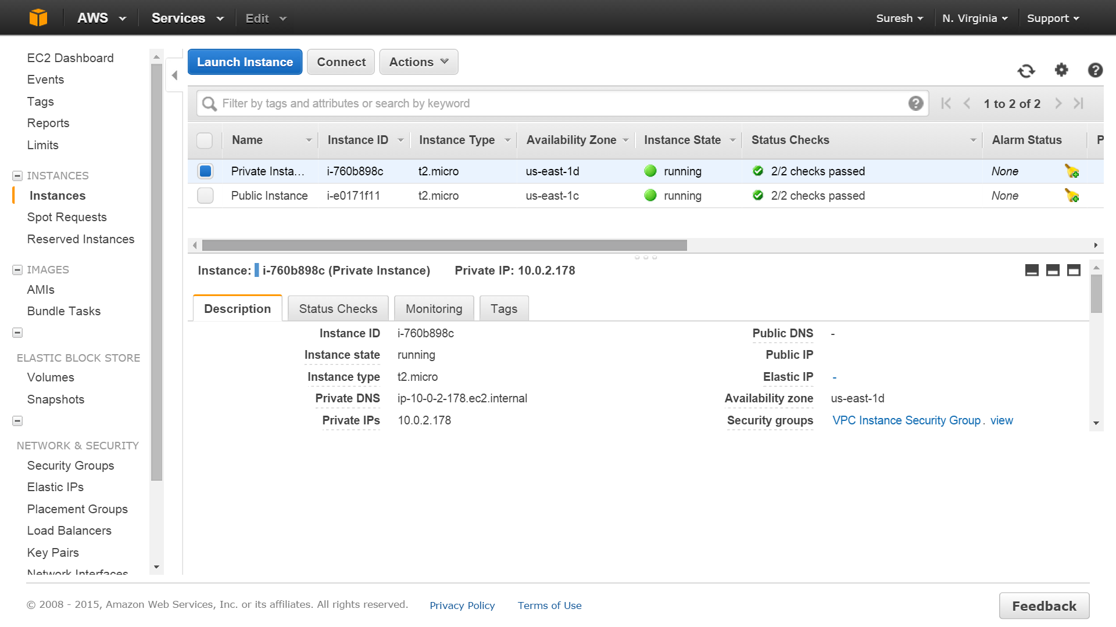

We cannot connect to either of the instances since both are private and have no public IP available for connection.

In order to connect to an instance, we must attach an Elastic IP and then connect the instance to the Internet Gateway

### Attaching Elastic IP and connecting to Internet Gateway

Attach an Elastic IP to any one of the instances. (Refer Exercise 9 on how to attach an Elastic IP to an instance). Once you attach an Elastic IP to an instance you will see the public IP being displayed.

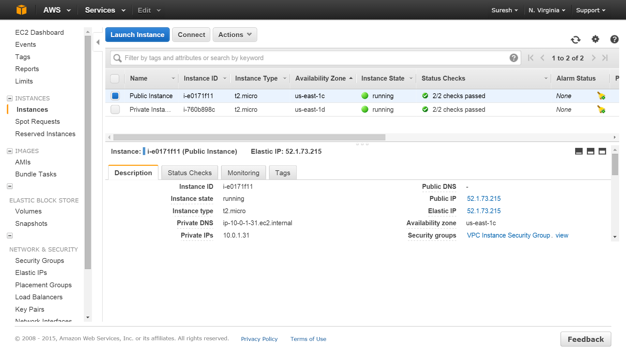

Attaching an Elastic IP is not sufficient to connect to the instance which is in a non-default VPC. You must also connect the subnet to the Internet Gateway.

You must now connect your subnet to the Internet Gateway. This is done through the routing table. Go to the VPC Dashboard. Click on ‘Subnets’ and select the subnet in which the instance with Elastic IP resides. Select the ‘Route Table’ tab and click ‘Edit’

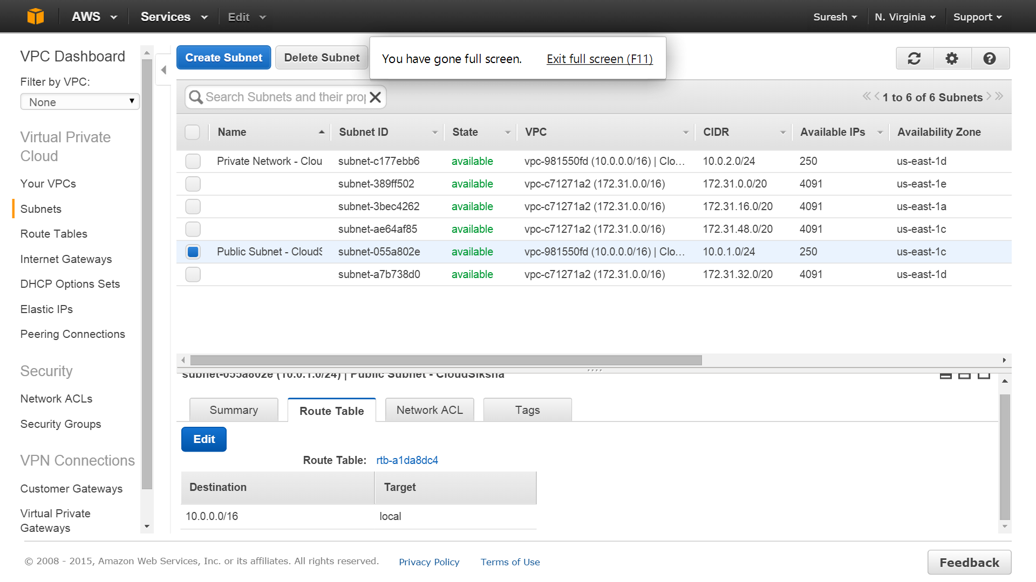

From the Change to: dropdown, select the route you had created earlier and press Save.

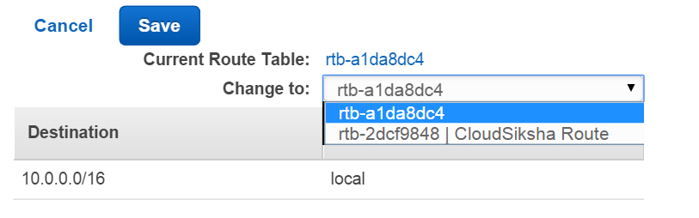

Now our subnet is associated with this route table. In other words, it is now connected to the Internet Gateway.

Now login into this instance using the Elastic IP Address (use PuTTY or SSH to login)

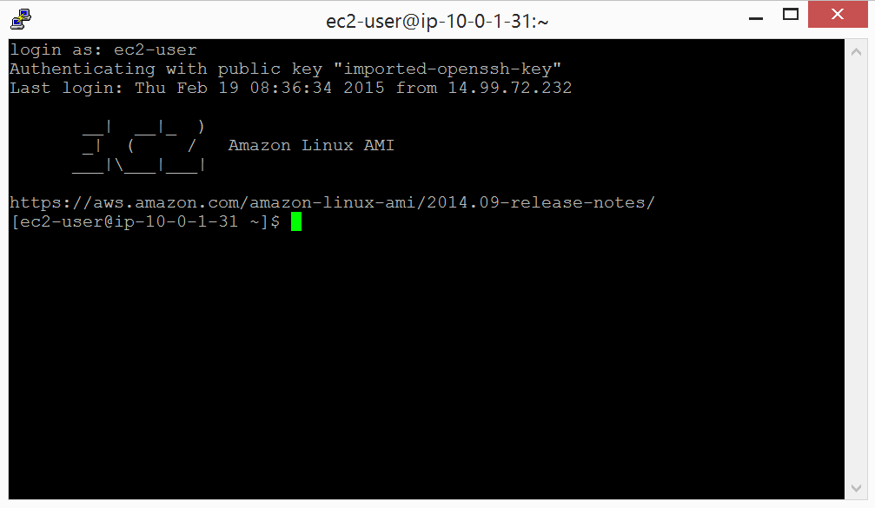

### Logging into the Private Instance

You can log into the private instance from the public instance, though the other private instance is on a different subnet and is a different region. This is because the route table allows for communication between subnets of the same VPC.

In order to login into the private instance from the public instance, do the following:

1. Note down the private IP of the private instance
2. Transfer the Key file (*.pem) to the public instance using WinSCP or FileZilla
3. Issue the SSH command to connect to the instance
   1. $ sudo ssh –i <file.pem> ec2-user@<PrivateIP>
4. You will now be connected to the private instance

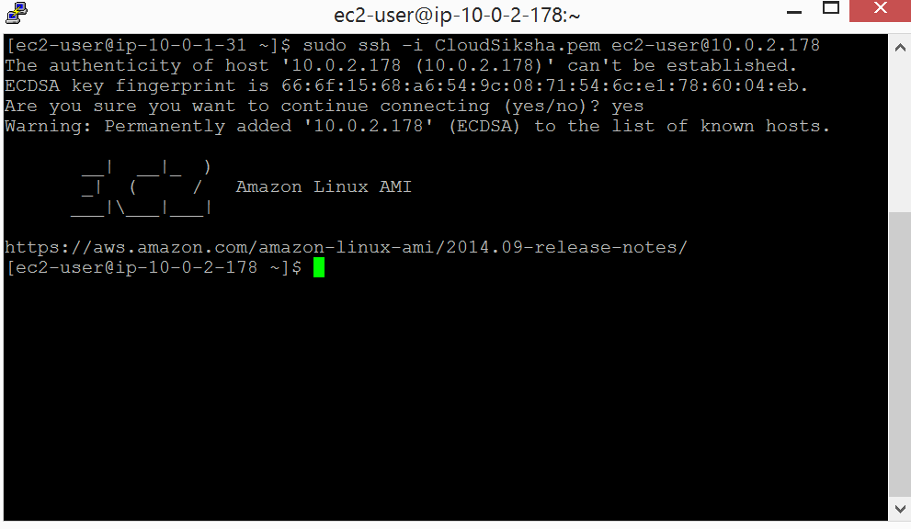

You have no successfully created a VPC, created subnets, launched instances into those subnets and connected to the public instance and through that to the private instance.

# Exercise 7

## Creating a NAT Gateway

As we saw earlier, private instances cannot communicate with the external world. This provides for a secure setup. At the same time, there will be occasions when the private instance need to be able to connect to the external world.

Minor or Major updates to software, installing security patches, raising a problem report in a vendor’s web site etc could be some of the reasons why private instances may need external world communication. This achieved using Network Address Translation or NAT

In this exercise you will learn how to launch a NAT Gateway and configure it.

On the VPC screen, click on NAT Gateways on the left side menu. Then click on ‘Create a NAT Gateway’ button

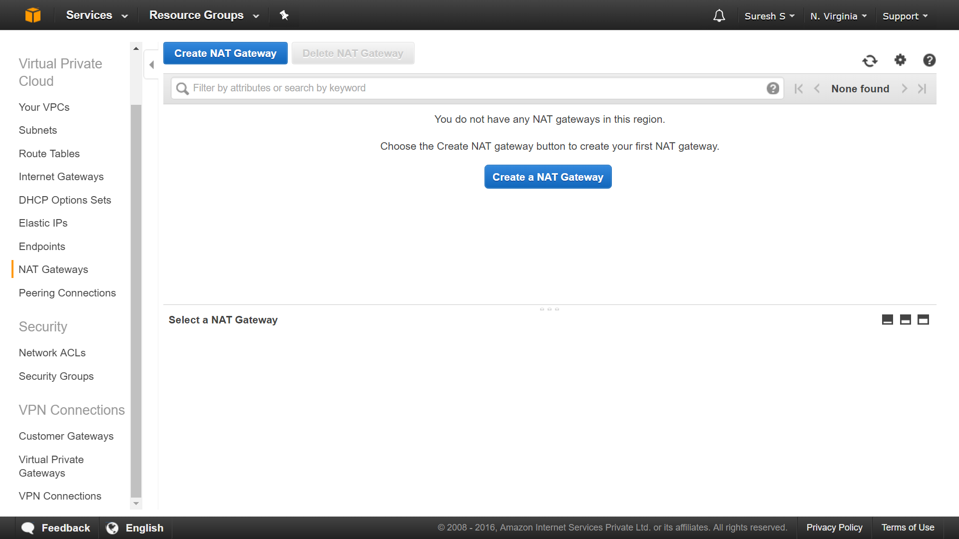

Select your Public Subnet in the Subnet field. (NAT Gateway must always be present in the public subnet since it has to access internet). Click on ‘Create New EIP’

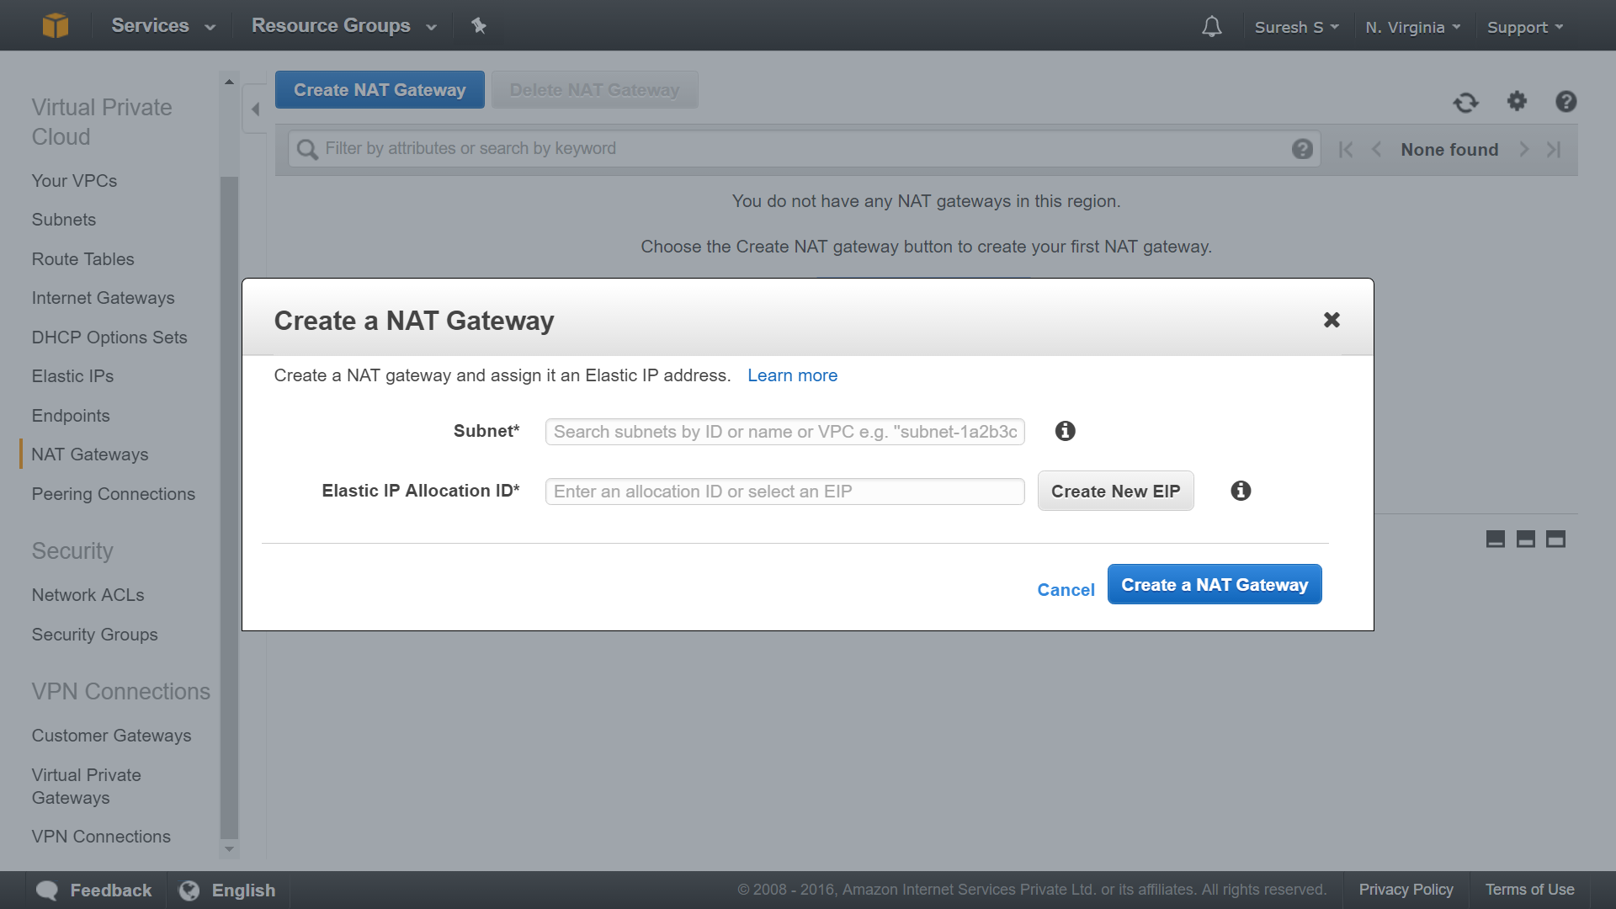

Your NAT Gateway will be created. (Be patient. It takes some time before NAT Gateway is active)

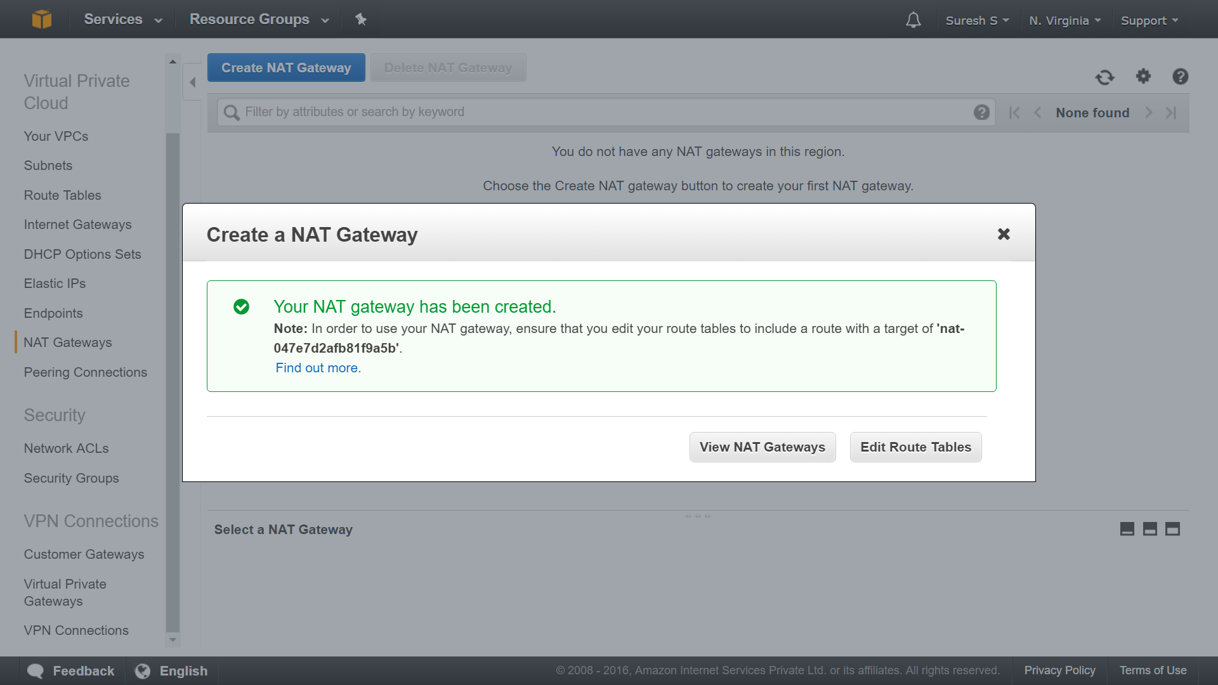

Now we need to route our private subnet to point to this NAT Gateway. We can do this is in two ways: a) Create a new routing table and attach it to the private subnet b) Change the master route table. (Changing master route table will affect all the subnets to which it is connected.)

We will change the master route table.

From the VPC menu, select Route Tables from the left side menu, select the master route table and click on the Routes tab below

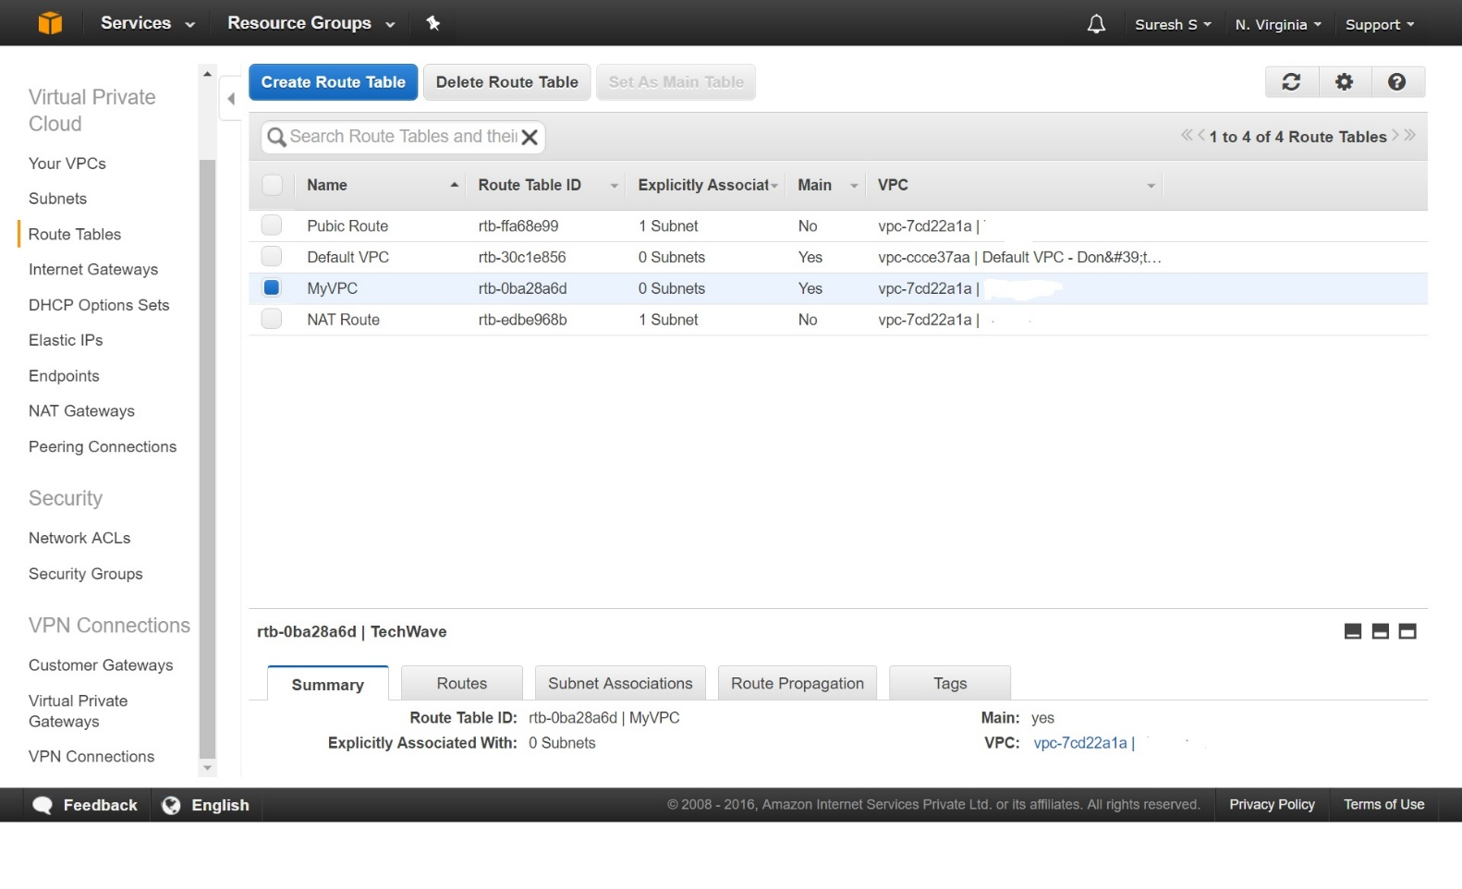

Select ‘Edit’ and then click on ‘Add another route’. In the destination field enter ‘0.0.0.0/0’ and click on the target field. You will see the Internet Gateway and the NAT Gateway popup in the target field. Select the NAT gateway. Then click ‘Save’

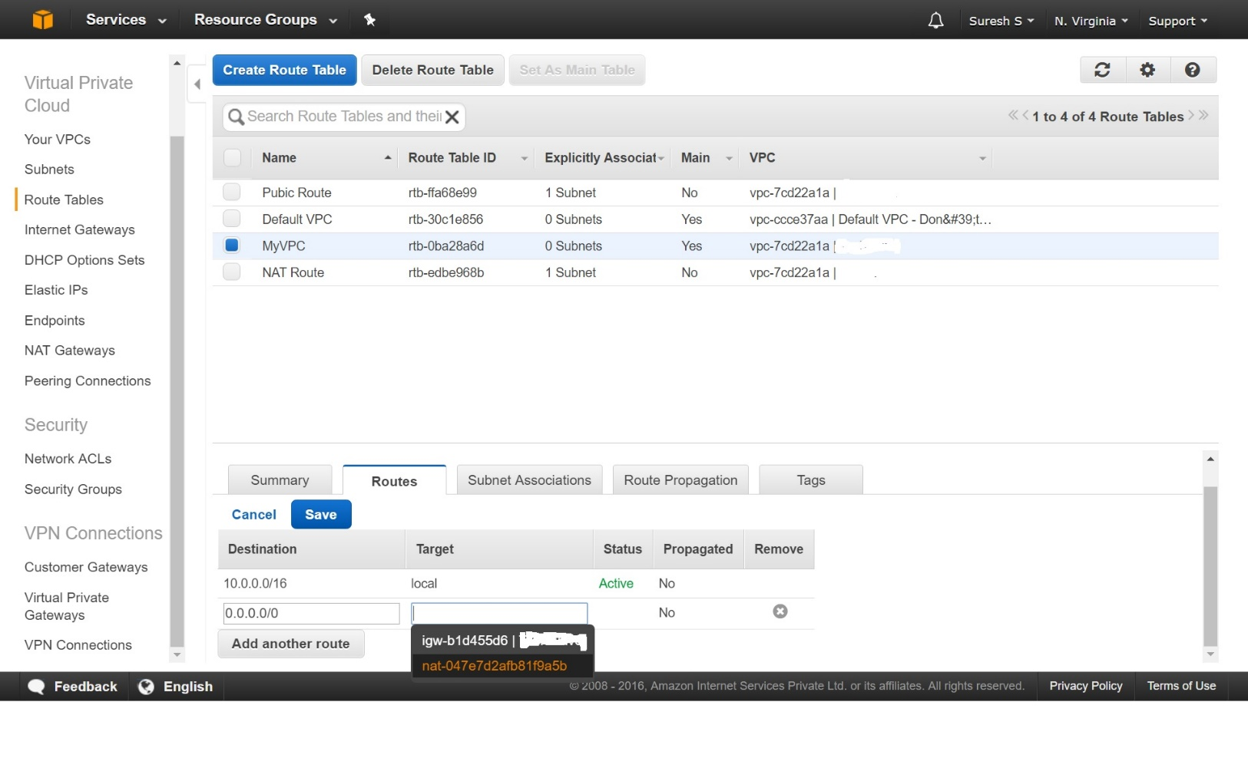

Now the NAT Gateway will help the private instance to connect to the internet.

From an instance in the private network, perform the following actions to check for internet connectivity

1. If you are using Windows instance, open Internet Explorer and try contacting ‘google.com’. Check is this is successful
2. If you are using Linux instance, issue the command, ‘wget [www.google.com](http://www.google.com)’. If you get a successful reply, then the NAT gateway is working fine

**Important Note:** NAT Gateway is not part of free tier. So delete it as soon as finish this exercise. You will incur an hourly cost of around Rs.7/-. If you do not terminate it, you will be charged on hourly basis till the time of termination.

# Exercise 8

## Identity and Access Management (IAM)

In this exercise, we will learn how to create users, how to create groups, how to provide permissions for users and group, how to create a role and assign it to an EC2 instance

### Creating an administrative user

Let us first create an administrative user. This user will have all the permissions of the root user (You are the root user when you login using your mail id and password. It is a suggested best practice by Amazon that we create an administrative user and login as administrative user instead of a root user)

From the AWS Console select ‘IAM’

Click on ‘Users’ to create the administrative user

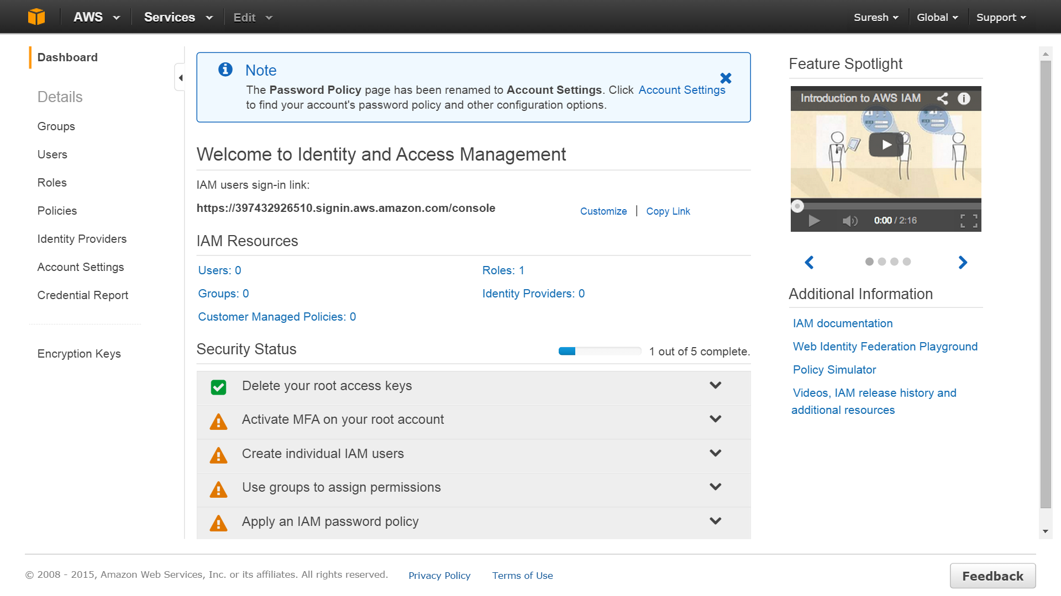

Click ‘Create Add Users’

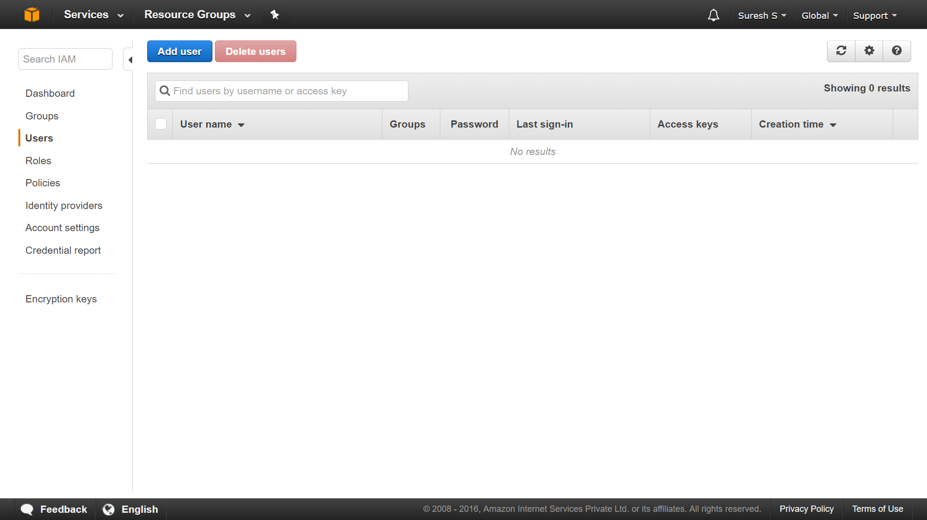

Enter ‘admin’ as the name of the user. Select ‘AWS Management Console Access’ and ‘Custom Password. Provide a Password in the custom password field

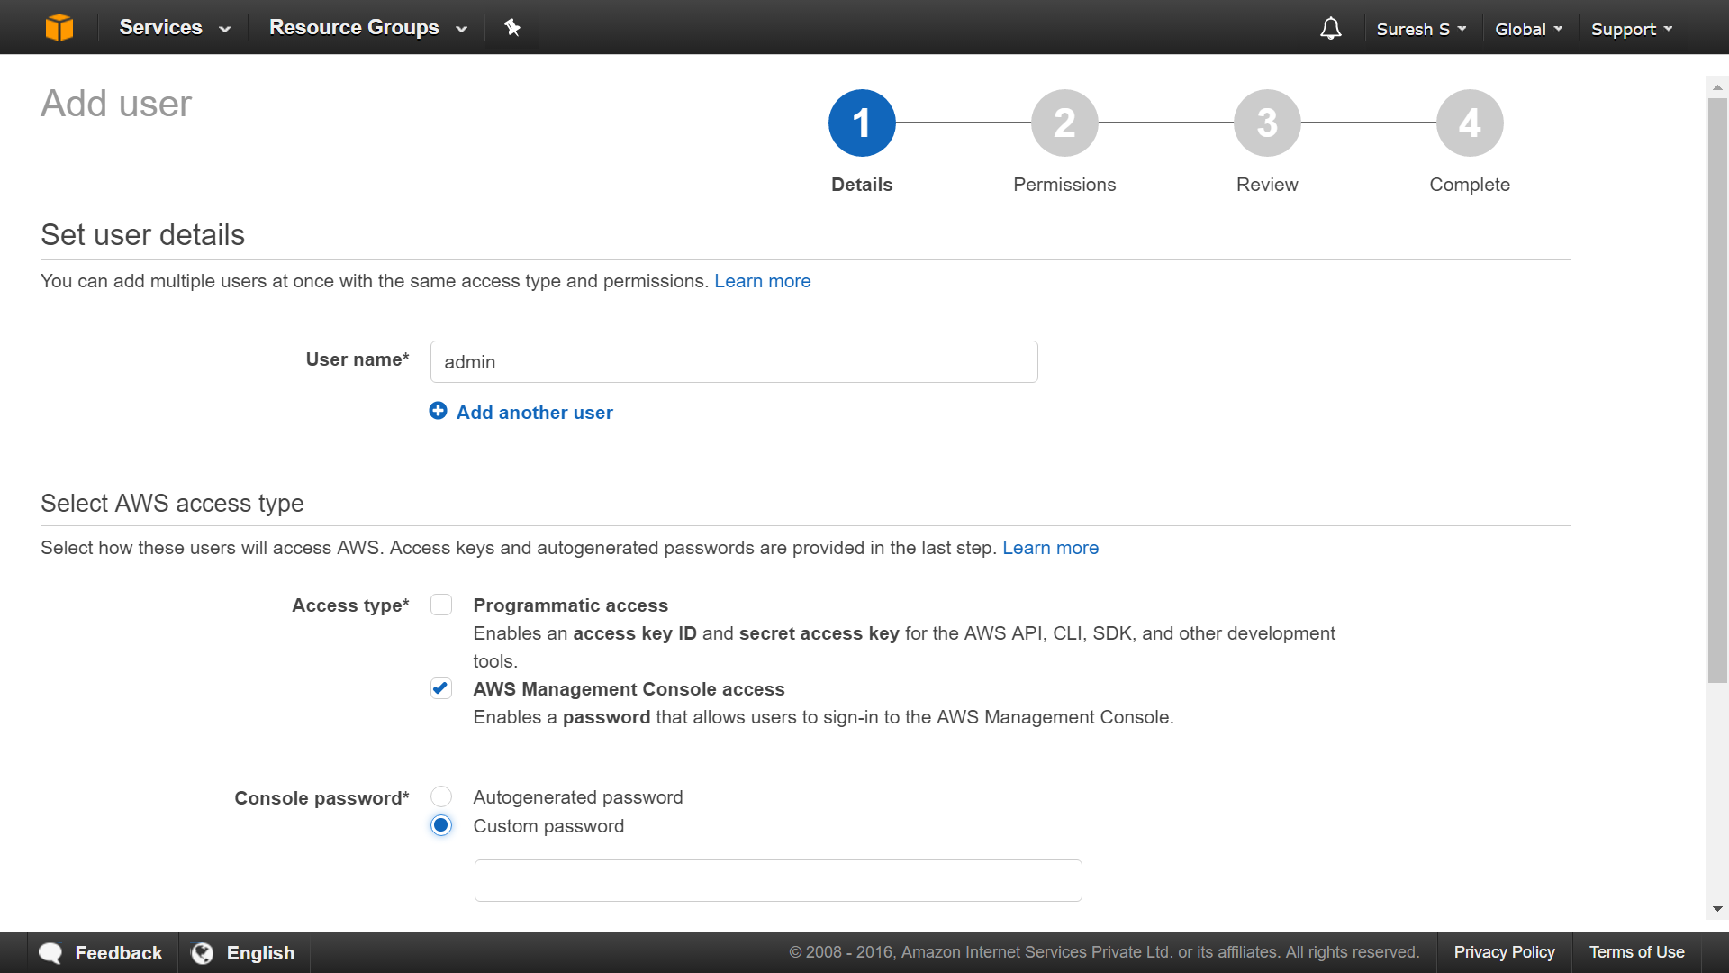

After entering a password, untick the ‘Require Password Reset’ and press ‘Next: Permissions’

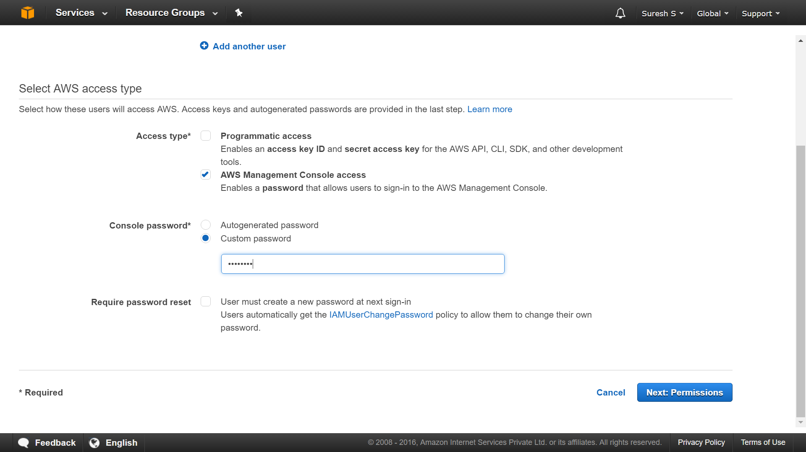

Select ‘Attach Existing Policies Directly’

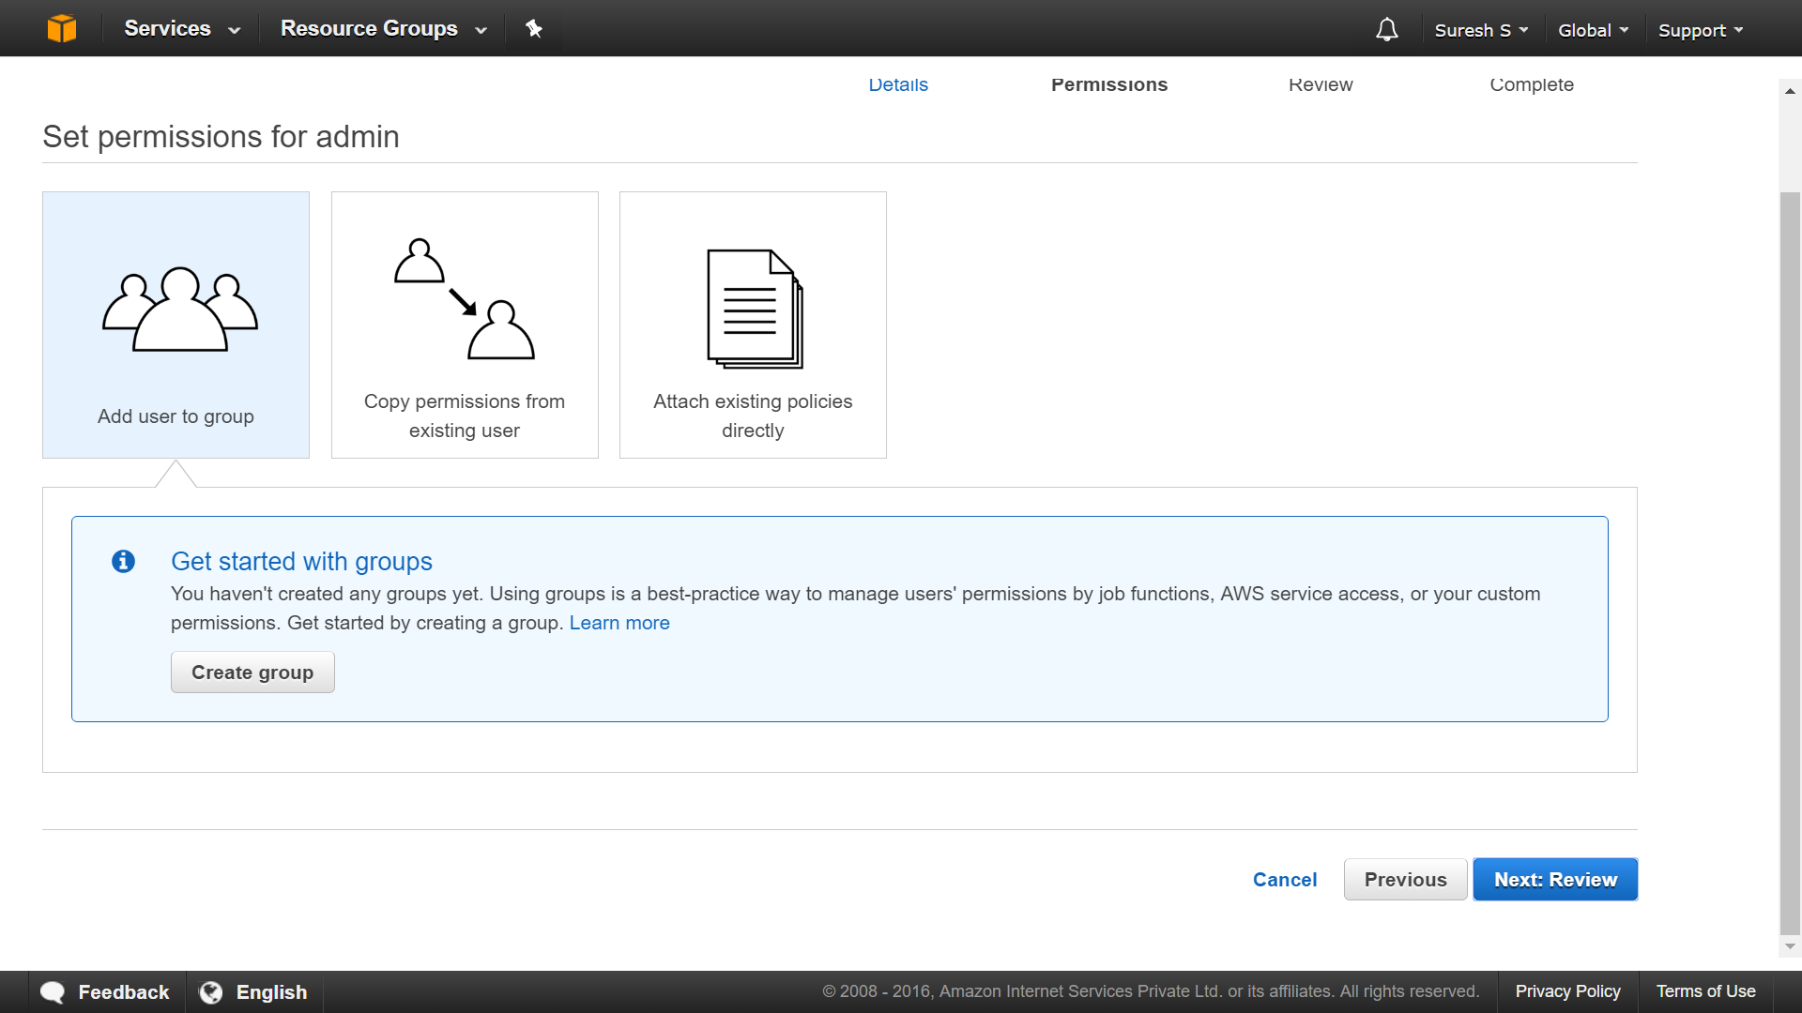

Search for ‘Administrator’ and then select ‘Administrator Access’ and press ‘Review

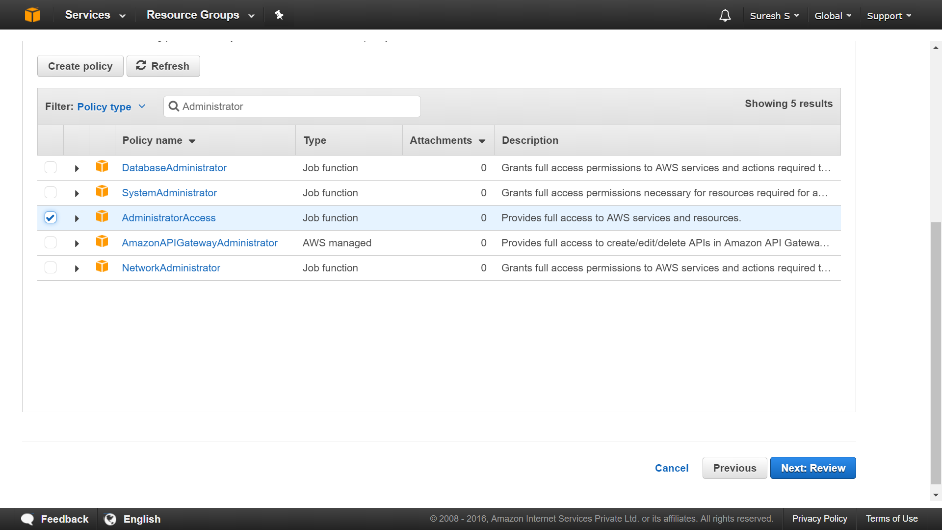

Review the details and if everything is fine, click on ‘Create User’

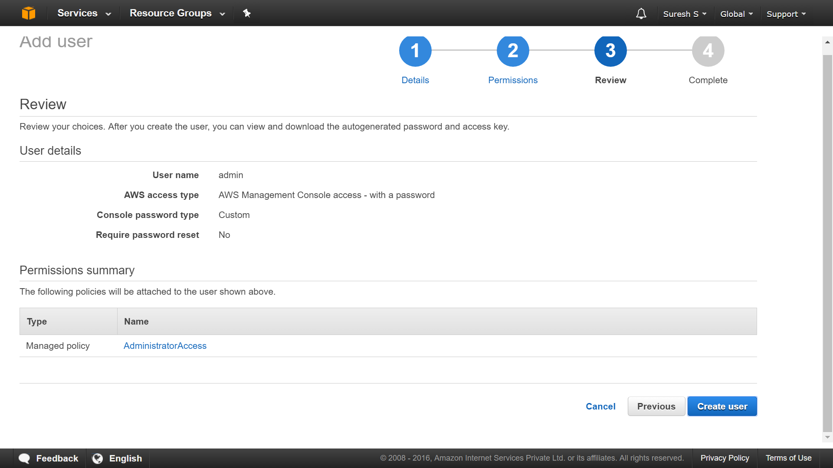

The user will be created and details of the user and how to login as the new user are displayed on this screen

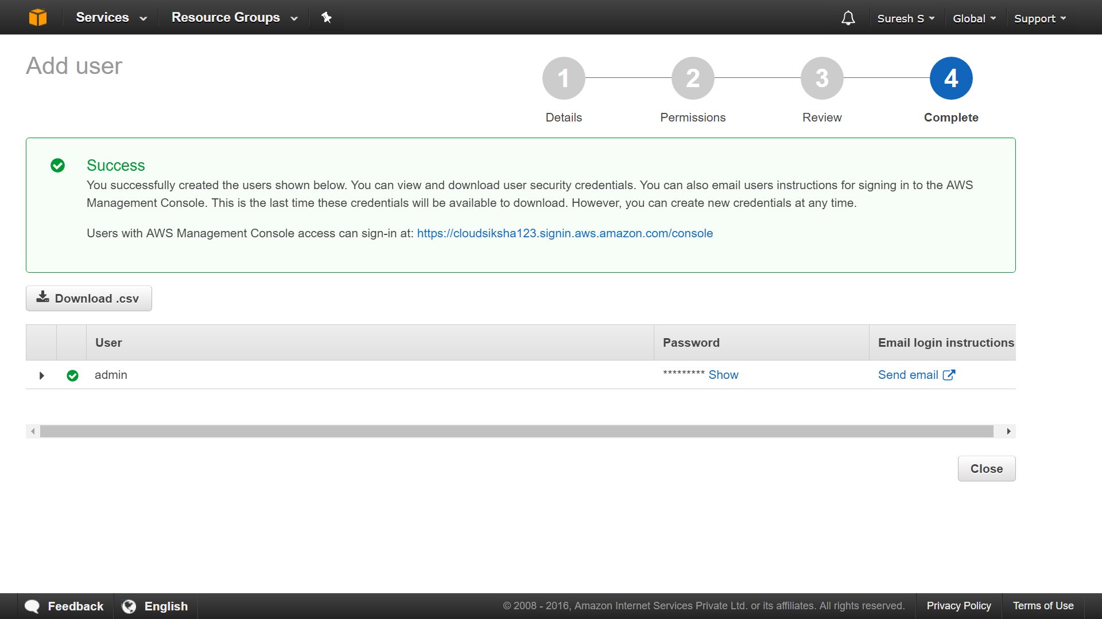

Click on ‘Dashboard’. You will find a new link provided which must be used to login into your Amazon account. Do not use the console login that you were doing earlier.

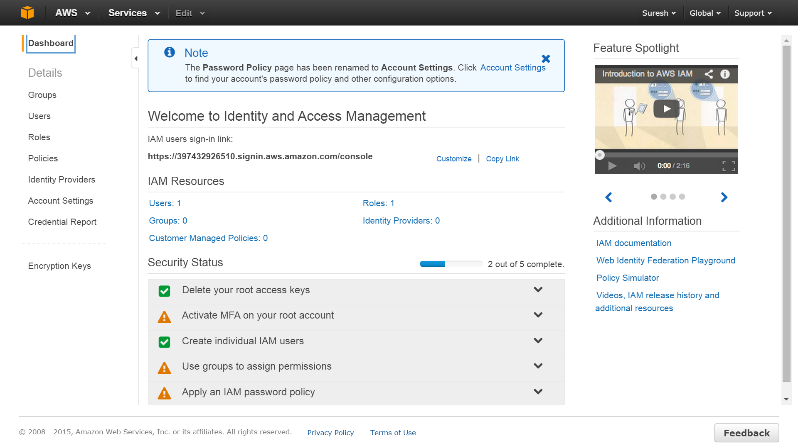

Save the URL. We will use this URL to login into our account

Open a new tab in the browser and paste the URL that you had copied. This will take you to the AWS Login screen. Once you have logged in, log off from the console (which you were logged into to create the admin user). All users must now use this URL to login into the console.

Login as ‘admin’ and provide the password that you had assigned to the account and login.

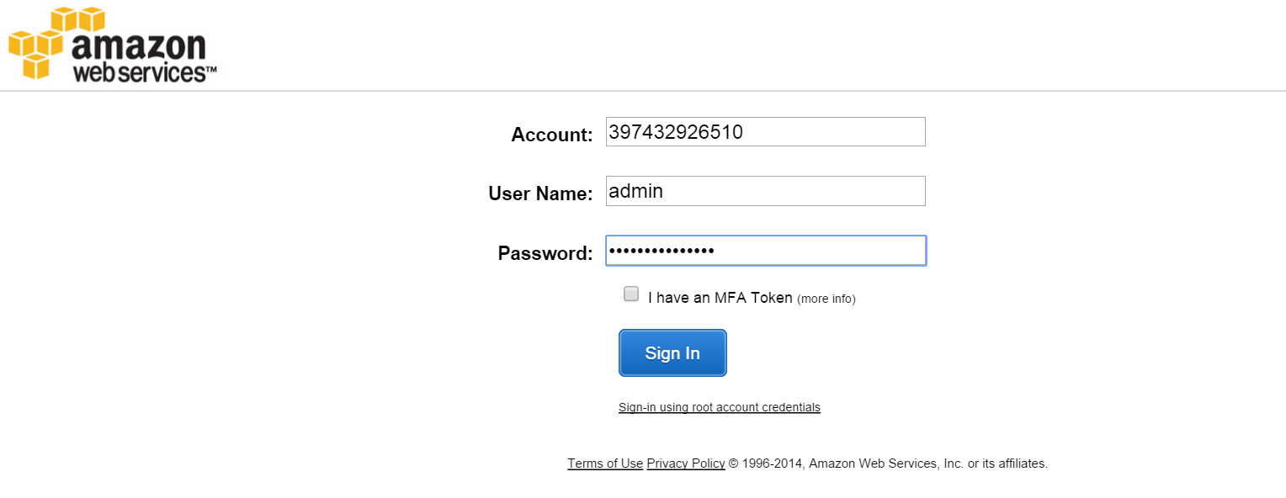

This will lead you to the AWS Console. You have successfully created an Administrative user and have logged in as the administrative user.

You can create any type of user (non-administrative) using the same method

### Creating Groups and assigning users

We have created users but we have not given them any permissions. We can go to individual user and attach a policy to them or we can create a Group with certain policies and add the users into the group. When users are added into a Group, they get the permissions of the group.

In the IAM Dashboard, click on Groups and then on ‘Create New Group’. Let us name this group as ‘Managers’. Click on ‘Next Step’

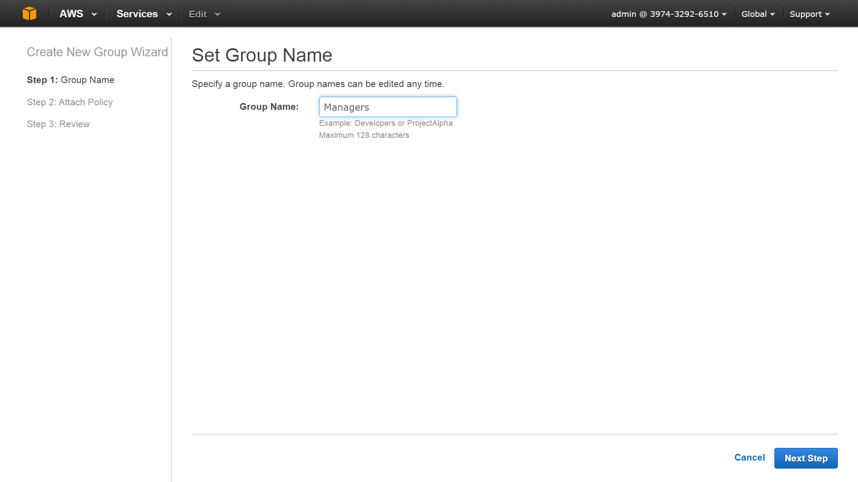

Choose ‘Amazon EC2 ReportsAccess’. This policy will give Managers access to EC2 Reports. Then click ‘Next Step’. Review the policy and click ‘Create Group’

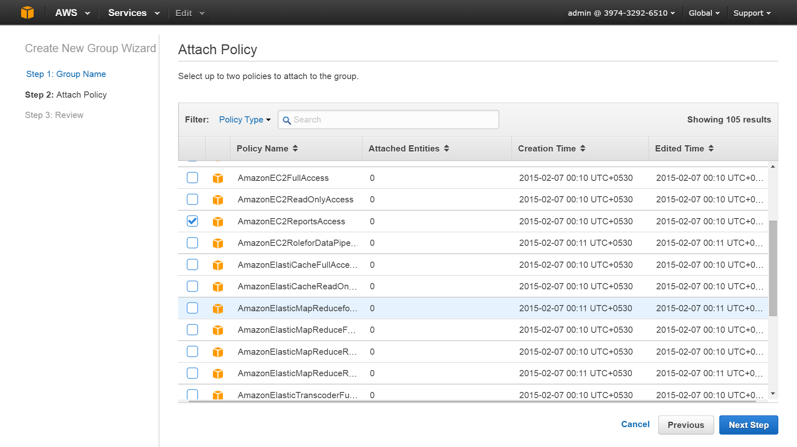

Now you will see a new group called Managers has been created. We will now add users into this group.

Select the Managers Group and click on ‘Group Actions’🡪 ‘Add Users to Group’

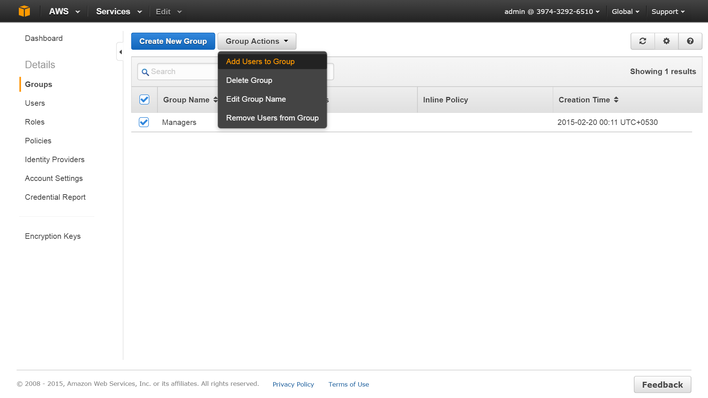

From the List of Users displayed select ‘Manager1’, ‘Manager2’ and ‘Manager3’ and Click on ‘Add User’. The users will be added to the Group. Now all the users will have the permissions of the Group. In this way, we can assign a set of users to a Group and avoid having to set a policy for each user.

### Creating Role and Assigning Role to an EC2 Instance

In this exercise we will create a role which will allow an EC2 instance to access S3 without having to provide credentials. Any application running on this EC2 instance can communicate with S3 without having to provide credentials. This ensures that credentials are not saved in the EC2 instance. Not storing credentials on EC2 instance is a best practice.

From the IAM Dashboard, click on Roles and then on ‘Create New Roles’. In the wizard, give a name to the role. Let us name this ‘S3 Access’

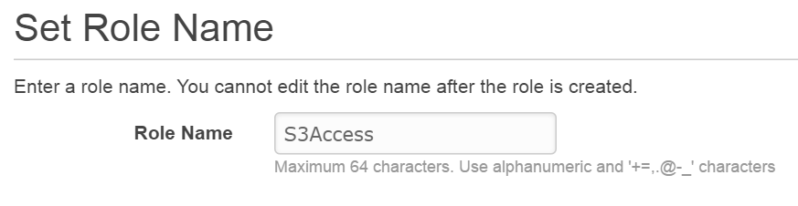

In the next ‘Select Role Type’ screen select ‘Amazon EC2’. This allows EC2 to request for AWS Services on our behalf.

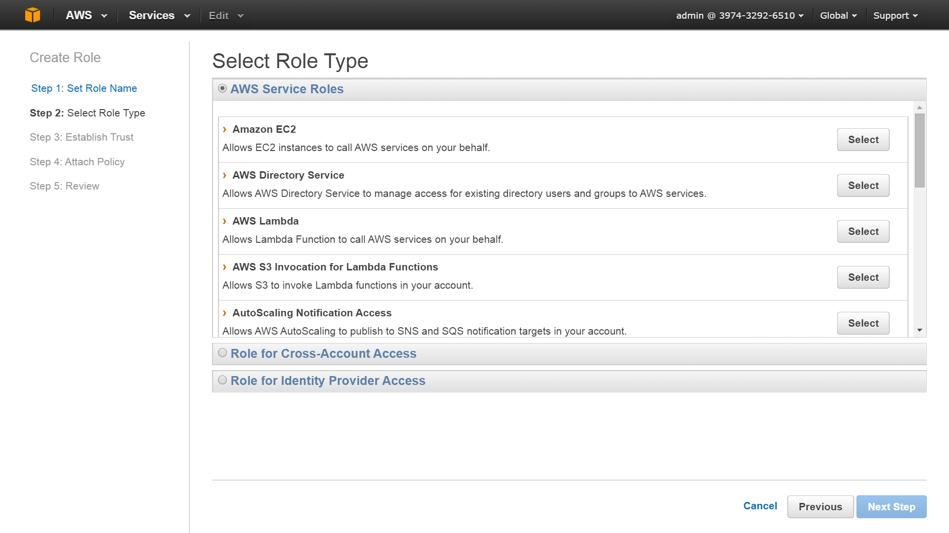

In the policy page, scroll down and select ‘Amazon S3 Full Access’. This will give EC2 instance full access to S3 services

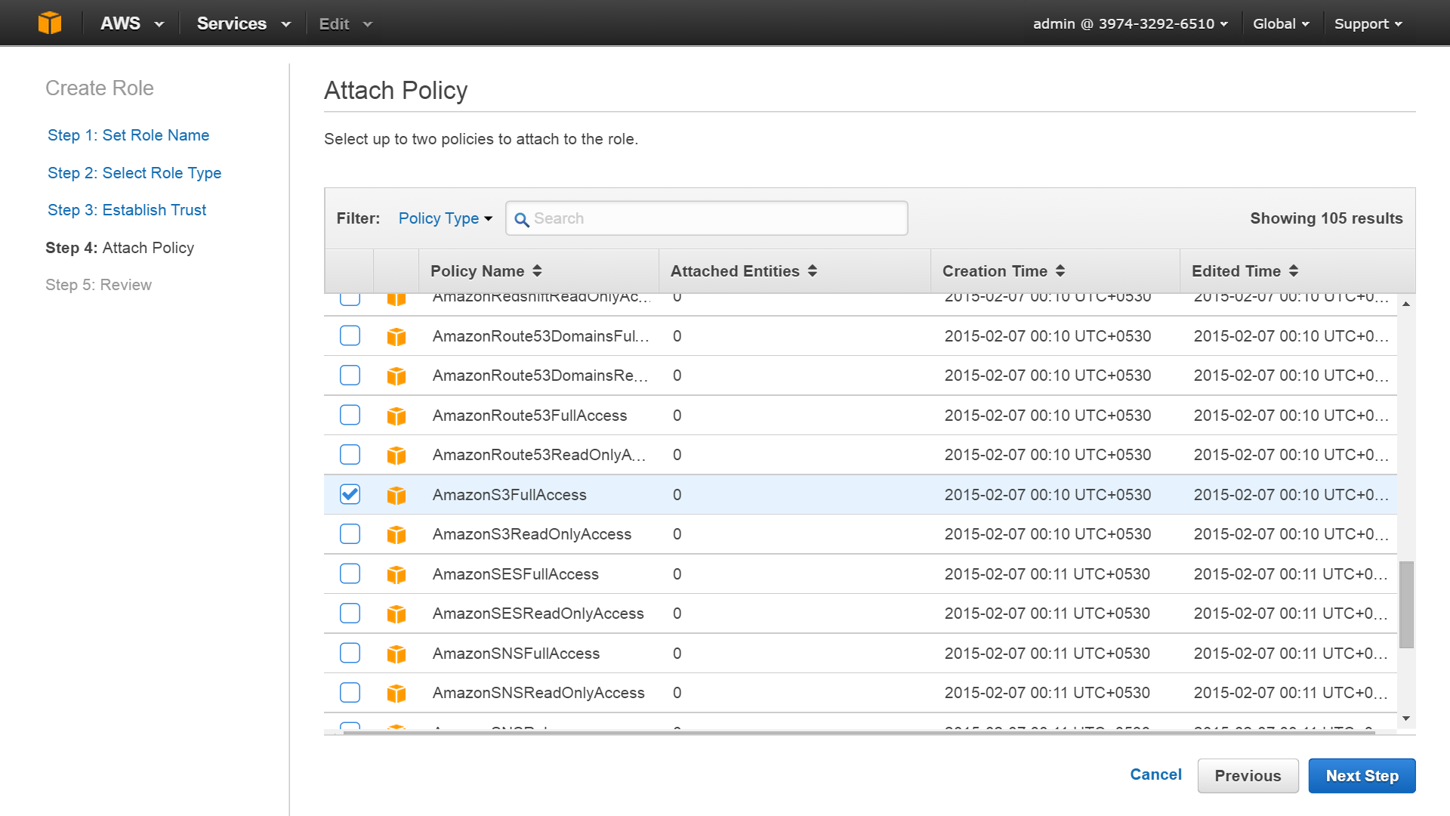

Review the details and click ‘Create Role’. The role will be created.

To demonstrate how a role helps, let us start two EC2 instances. Start the first instance the default way. For the second instance, in the ‘Configure Instance Detail Screen’ in the IAM role dropdown, select ‘S3Access’ as the role.

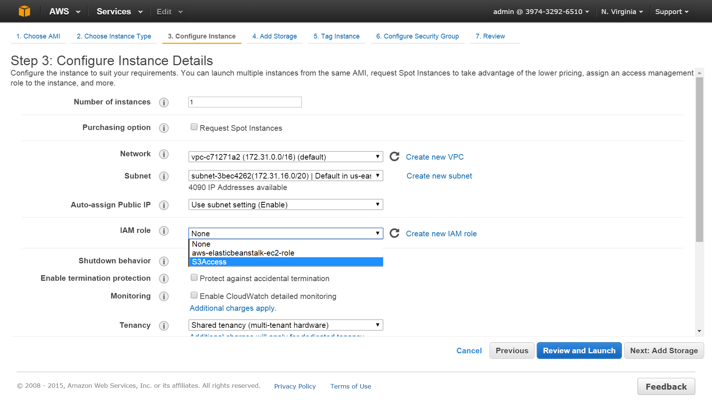

After selecting this role, go ahead and launch the instance.

Once the instances are started, we will connect to both the instances, download the AWS CLI and issue a simple aws s3 ls command. This command will list the buckets present in S3. We will observe that this will succeed only in the EC2 instance which has the role defined.

Login into both the instances and issues the following commands to download the AWS CLI.

$ sudo yum install python-pip

$ sudo pip install awscli

This will install the AWS CLI on your instance. Do this on both the instances

Now run this command:

$ aws s3 ls

You will get an error, ‘Unable to locate credentials’ in the instance which does not have the role

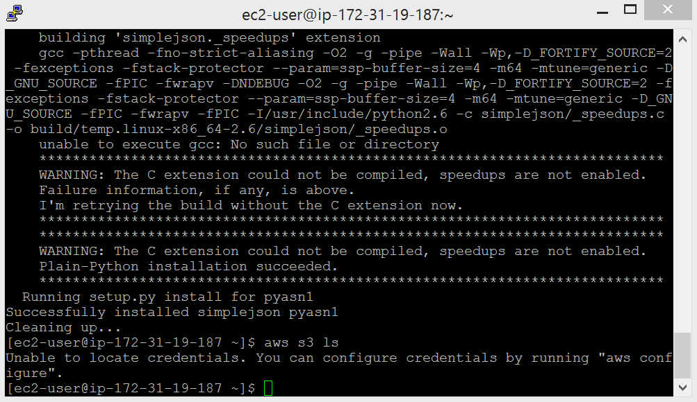

Whereas the EC2 with the role will display the bucket names against the command.

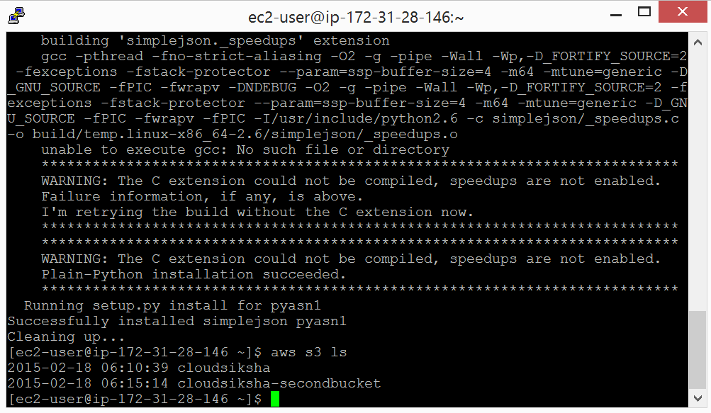

This ends our IAM exercises.